CSS ISLAMIAT MCQs

2013

Part-I
Q.No.1.
1. The largest Surah of the Quran is:
a. Al-Baqrah
b. Aali Imran
c. Al-Taubah
d. Surah Younus
e. None of these
2. Fidk Garden was bestowed to the Holy Prophet (SAW) as:
a. Fay
b. Booty
c. Gift
d. Loan
e. None of these
3. Arbeen is the book of Hadith in which there are:
a. 40 Ahadith
b. 50 Ahadith
c. 30 Ahadith
d. 20 Ahadith
e. None of these
4. The heads of Zakat are:
a. 8
b. 9
c. 7
d. 5
e. None of these

5. Mauwazatain mean:
a. A Collection of Ahadith
b. Two specific Surah of Quran
c. A book of Jafferi Fiqh
d. A book of Hanafi Fiqh
e. None of these
6. The numbers of famous months are:
a. 4
b. 6
c. 7
d. 2
e. None of these
7. Jabal-e-Noor is situated in:
a. Arafat
b. Ghar-i-Hira
c. Ghar-i-Saur
d. Madinah
e. None of these
8. Which country is known as the “Land of Prophet”?
a. Iraq
b. Saudi Arabia
c. Palestine
d. Syria
e. None of these
9. Zou-Shahadatein is the title of Hazrat:
a. Khuzaima Bin Sabit (RA)
b. Huzaifa Bin Yaman (RA)
c. Ammar Bin Yasir (RA)
d. Imam Abu Hanifa
e. None of these

10. Sura Saba i:
a. Makki
b. Madani
c. Iraqi
d. Makki Madni
e. None of these
11. Which Surah of Quran has Bismillah twice?
a. Al-Nahal
b. Al-Namal
c. Al-Ahzab
d. Al-Noor
e. None of these
12. Imam-e-Darul-Hijra was a title of:
a. Imam Ahmad
b. Imam Maalik
c. Imam Shafai
d. Imam Muhammad
e. None of these
13. Masjid Qiblatain is situated in:
a. Madinah
b. Makkah
c. Taif
d. Jabal e Noor
e. None of these
14. Which is a religious book of Hinduism?
a. Injeel
b. Taurat
c. Ramain
d. Bibel
e. None of these

15. The first Islamic month is:
a. Muharram
b. Zil Hajjah
c. Safar
d. Rajab
e. None of these
16. Which was the total number of idols were in the Kaaba?
a. 260
b. 360
c. 460
d. 560
e. None of these
17. Batha Valley is situated in:
a. Makkah
b. Madinah
c. Iraq
d. Jordan
e. None of these
18. Hazrat Muhammad (SAW) gave the key of Bait-Ullah permanently to:
a. Ummrah bin Utba
b. Hanzla bin Abil Amir
c. Usman Bin Talha
d. Abdullah bin Amir
e. None of these
19. AshabusSabt mean:
a. Jews
b. Christians
c. Muslims
d. Sabieen
e. None of these

20. The word Muhammad (SAW) as a name has been mentioned in Quran only:
a. Two time
b. Four time
c. Six time
d. Seven time
e. None of these

2011

Part 1 MCQ’s
Q.1 Select the best option/answer and fill in the appropriate box on the answer sheet
(i) mention the religious book(s) of Buddism:
(a) Weena pataka
(b) Sata pataka
(c) Abhi dhaman pataka
(d) All of these
(e) None of these
(ii) What was the Religious of the majority of the Arabs before Islam?
(a) Buddhism
(b) Jewish
(c) Idolatrous
(d) Christianity
(e) None of these
(iii) Name of the son of Hazarat Yaqoob (A.S) whose off-springs are the Jews.
(a) Tibrani
(b) Yahooda
(c) Ishaq (a.s)
(d) Yousaf (a.s)
(e) None of these
(iv) which book is called old testament?
(a) zuboor
(b) torait
(c) injeel
(d) quran
(e) none of these
(v) What was the total number of idols which were fixed around the Kaaba?
(a) 260
(b) 360
(c) 460
(d) 560
(e) None of these
(vi) Hazrat Muhammad (PBUH) was born about three thousands years, after:
(a) Hazrat Ismaeel (A.S)
(b) Hazrat Ibraheem (A.S)
(c) Hazrat Moosa (A.S)
(d) Hazrat Eessaa (A.S)
(e) None of these
(vii) Who suggested name “Ahmed” for the Holy Prophet (PBUH)?
(a) Hazrat Abdul Mutalib
(b) Hazrat Abu Talib
(c) Hazrat Abdullah
(d) Hazrat Hamza (R.A)
(e) None of these
(viii) When Hazrat Umer (R.A) embraced Islam?
(a) 600 A.D
(b) 608 A.D
(c) 612 A.D
(d) 616 A.D
(e) None of these
(ix) Zou-Shadatian is title of Hazrat:
(a) Khuzaima bin Sabit (R.A)
(b) Huzaifa bin Yaman (R.A)
(c) Ammar bin Yasir (R.A)
(d) Ahmed bin Hanbal
(e) None of these

(x) Which country is known as the “Land of Prophets”?
(a) Iraq
(b) Saudi Arabia
(c) Palestine
(d) Syria
(e) None of these
(xi) What is Tahleel?
(a) Recitation of 4th kalima
(b) Recitation of 3rd kalima
(c) Recitation of 2nd kalima
(d) Recitation of 1st kalima
(e) None of these
(xii) Name the 8th months of Islamic Calendar.
(a) Rabi-ul-Awal
(b) Rajab
(c) Ramzan
(d) Shaban
(e) None of these
(xiii) 9th Zil-Hajja is also called:
(a) Yaum-e-Arfat
(b) Waquf-e-Arafat
(c) Yaum-e-Mina
(d) Waqufe-e-Mina
(e) None of these
(xiv) Name the 1st man who issued regular order to collect and write Ahadis:
(a) Hazrat Umer bin khattab (R.A)
(b) Hazrat Usman bin Affan (R.A)
(c) Hazrat Ali bin Abu Talib (R.A)
(d) Hazrat Umer bin Abdul Aziz (R.A)
(e) None of these

(xv) The duration of third period of the compilation of Hadis is:
(a) 171 to 220 A.H
(b) 171 to 221 A.H
(c) 171 to 222 A.H
(d) 171 to 223 A.H
(e) None of these

(xvi) Surah Hajj consist of 10 Rukus and _________ Ayats.
(a) 70
(b) 75
(c) 78
(d) 82
(e) None of these
(xvii) Surah Saba is:
(a) Makki
(b) Madni
(c) Iraqi
(d) Makki madni
(e) None of these
(xviii) Who considered the Quran as the creature of Allah?
(a) Khawarji
(b) Mo,atazila
(c) Shami
(d) Kuif
(e) None of these
(xix) To which tribe did Hazrat Khalid-bin-Waleed (R.A) belong?
(a) Banu Ummayya
(b) Banu Asad
(c) Banu Zuhra
(d) Banu Makhzoom
(e) None of these

(xx) Which Sahabi was died in the hands of the Holy Prophet (PBUH) in the battle of Uhad?
(a) Hazrat Haris-bin-Haris (R.A)
(b) Hazrat Haris-bin-Azima (R.A)
(c) Hazrat Haris-bin-Hassan (R.A)
(d) Hazrat Haris-bin-Hakeem (R.A)
(e) None of these

2010

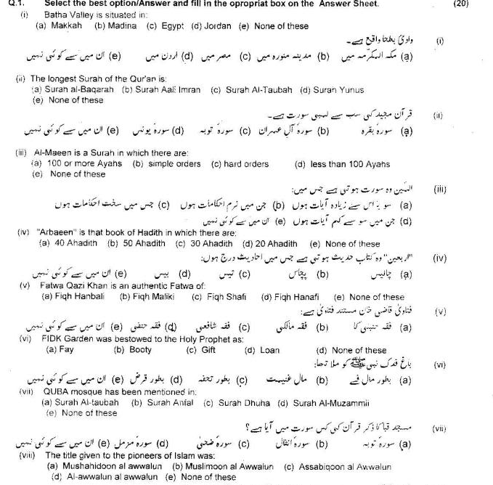

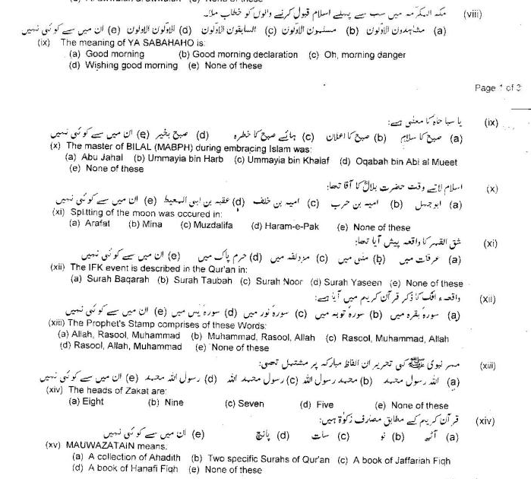

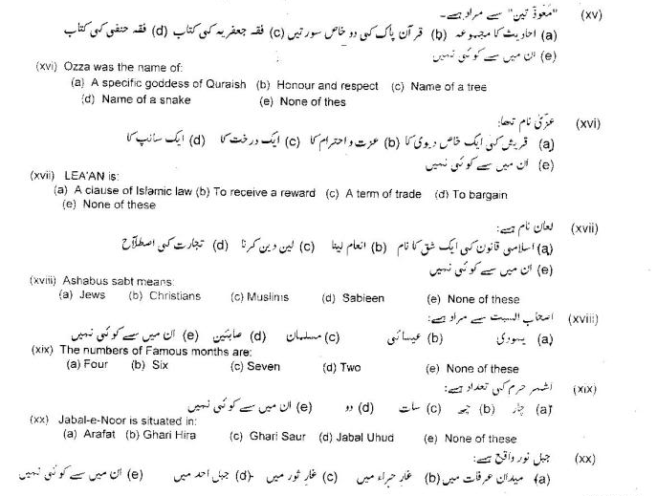

2009

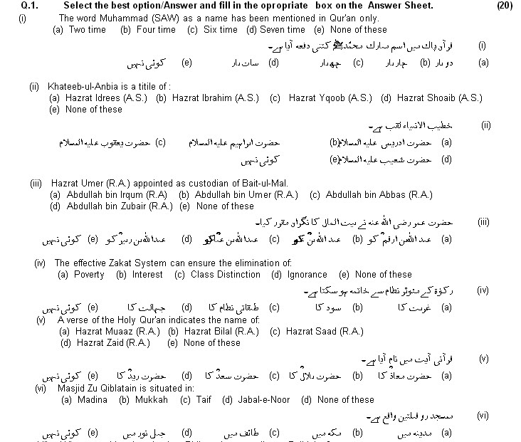

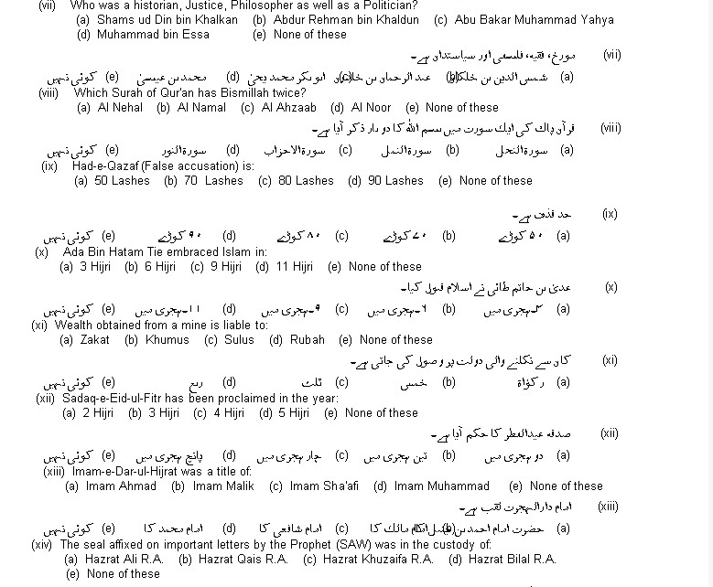

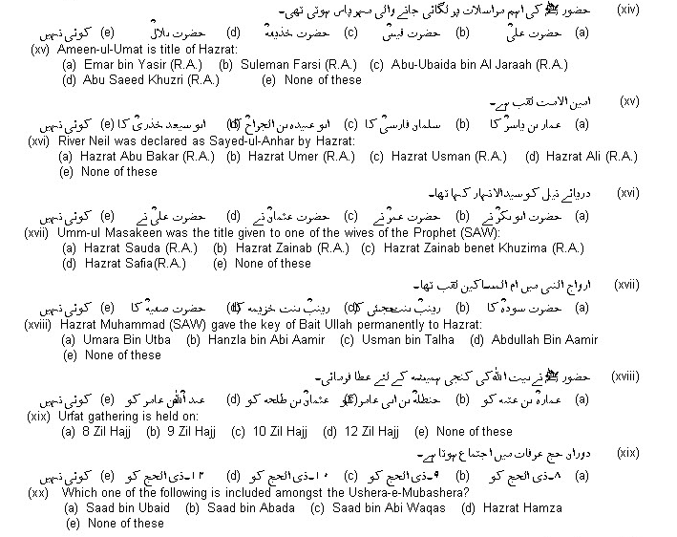

2008

Q.1.
i. Who advised Abu Bakr (R.A) to compile the Quran:
a. Hazrat Umar (R.A)
b. Hazrat Uthman (R.A)
c. Hazrat Ali (R.A)
d. Hazrat Zaid (R.A)
ii. The Nisab of Zakat in Silver is:
a. 40 Tolas
b. 50 Tolas
c. 50 ½ Tolas
d. 52 ½ Tolas
iii. The Prophet made Hazrat Muaaz bin Jabal the Governor of:
a. Kufa
b. Makkah
c. Medina
d. Yaman
iv. Who are the “Sahibain”?
a. Abu Hanifah and Abu Yusuf
b. Abu Hanifah and Imam Shaibani
c. Abu Yusuf and Imam Shaibani
d. Abu Hanifah and Imam Shafi

v. Hajj is not completed unless you go to:
a. Makkah
b. Medina
c. Mina
d. Arafat
vi. “Kitab-al-Umm” is written by:
a. Abu Hanifa
b. Imam Malik
c. Imam Shafi
d. Ahmad bin Hambal
vii. The foundation of Bait Ul-Hikmah was laid down during:
a. Abbasid Period
b. Ummayad Dynasty
c. Fatmid
d. Sub-Continent
viii. What is the number of month “Rajab” in Islamic Calendar?
a. First
b. 7th
c. 5th
d. Eleventh
ix. First Mujadid was Hazrat Umar bin Abdul Aziz. Who was the second one?
a. Ibn-e-Taimya
b. Imam Ghizali
c. Ahmad Sirhindi
d. Shah Waliullah

x. Sahifa Hammam bin Munabih was found by:
a. Mufti M. Abduhu
b. Rasheed Ahmad Raza
c. Dr. Hamidullah
d. Dr. Zakir Naik
xi. In which Surat of Quran there is mention of Zulqarnain?
a. A’ssuff
b. Alkahaf
c. Al Mujadala
xii. Muslims are the best of all due to:
a. Justice
b. Moderation
c. Truthfulness
xiii. Sahib Us-Ser is the nickname of:
a. Hazrat Khuzaifa (R.A)
b. Hazrat Uqba (R.A)
c. Hazrat Saad (R.A)
xiv. Masjide Khief is located in:
a. Muzdilifa
b. Arafaat
c. Minna
xv. Ghaseel ul Malaika is the title of:
a. Hazrat Abu Talha (R.A)
b. Hazrat Abu Dahana (R.A)
c. Hazrat Hanzala (R.A)
d. Hazrat Saad (R.A)
xvi. Who was appointed as usher for Hijrat-e-Madinah?
a. Hazrat Saad bin Ubada (R.A)
b. Hazrat Utab bin Usaid (R.A)
c. Hazrat Abdullah bin Ariqat (R.A)
xvii. Who was a historian jurist, philosopher, as well as a politician?
a. Shams uddin Ibni Khalkan
b. Abdur Rehman Ibni Khaldoon
c. Abu Bakar Muhammad Ibni Yahya
xviii. When law of inheritence was revealed?
a. Three Hijre
b. Four Hijree
c. Five Hijree
xix. Who was the last Commander in Chief for Ghazwa-e-Mautah?
a. Hazrat Khalid bin Waleed (R.A)
b. Abdur Rehman bin Auf (R.A)
c. Abdullah bin Rawaha (R.A)
xx. Imam Dar ul Hijrat is the title of:
a. Imam Ahmad bin Hunbal
b. Imam Malik
c. Imam Shafee

2007

Q.1
1. How many stages the Quran contains? .
(a) 8
(b) 7
(c) 9
(d) 12
2. Who was the first writer of "wahi" in Quraish?
(a) Harat Abdul Rahman bin Auf (RA)
(b) Hazrat Zaid bin Sabit (RA)
(c) Hazrat Abdulla bin Zubair (RA)
(d) Hazrat Ibn Masuod (RA)
3. Kitab-ul-Assar is compiled by:
(a) Imam Abu Hanifah (RA)
(b) Imam Shafi (RA)
(c) Imam Malik (RA)
(d) Imam Humbal (RA)
4. Imam Shafi took the office of "Religious Judgment" in the age of:
(a) 13 years
(b) 14 years
(c) 20 years
(d) 15 years
5. What was the name of faster sister of the Holy Prophet (PBUH)?
(a) Hazrat Salmah (RA)
(b) Hazrat Raqiyyah (RA)
(c) Hazrat Mariah (RA)
(d) Hazrat Shima (RA)
6. Namaz-e-Istisqa" is prayer for:
(a) Blessing of God
(b) Pardon
(c) Rain
(d) Sleep
7. Who is called "saqi zam zam"?
(a) Hazrat Abbas (RA)
(b) Hazrat Hamzah (RA)
(c) Hazrat Muaz bin Jabal (RA)
(d) Hazrat Muawiyah (RA)
8. The "Kissing of the Hajr-e-Aswad" is called:
(a) Saee
(b) Mabroor
(c) Istelam
(d) Shaut
9. What is the number of Ramzan in the Islamic Calender?
(a) 8th
(b) 9th
(c) 10th
(d) 11th
10. Give the name, who compiled first work of Hadith "Sahifa-e-Sadiqa."
(a) Hazrat Abu Bakar (RA)
(b) Imam Muslim (RA)
(c) Hazrat Abdullah bin Amr (RA)
(d) Hazrat Abu Hurairah (RA)

2006

1, How Much Surah The Quran Contains,
A,124 B,109 C,114, D,220
2,the Nisab Of Zakat In Gold Is;
A,18 Tolas B,24,tolas C,7 ½ Tolas D,35 Tolas
3,a Verse Of The Holy Quran Indicates The Name Of;
A,hazrat Usman B,hazrat Muaaz C,hazrat Saad D,hazrat Zaid
4, A Muslim Female Is Coffined In;
A,eight Sheets B,five Sheets C,one Sheet D,ten Sheets
5,the Original Name Of Imam Bukhari Is.
A,saeed B.hatem B,ali B.zaid C,ismail D,muhammad B.
6,makka Was Conquered In.
A,5 A.h B,10 A.h C,2 A.h D,8 A.h
7,qurbani (holy Slaugtering)is Made During Hajj At"
A,arafat B,mina C,muzdalifa D,safa
8,jami-quran Is Taken For;
A,hazrat Ali B,hazrat Saad C,hazrat Usman D,hazrat Masood
9, Pious-caliphate Lasted For About;
A,eighteen Years B,twenty Years C,thirty Years D,five Years
10,gathering On Arafat During Hajj Is Made On:
A,9th Zil Hajjah B,3rd Ramazan C,2nd Safar D,18 Shawal

2005

1). Which surah starts without Bismillah
a) Al-Baqara b) Al-Nisa c) Al-Toba d) Al-Ikhlas
2). A male is coffined/wrapped in __ dressed sheets
a) 1 b) 2 c) 3 d) 4
3). Amount of zakat cannot be used in _____
a) madrassah b) mosque c) hospital
4). What is sahlihain
a) mishkat b) bukhari c) bukhari and muslim d) ibne majah
5). Jehad become mandatory in ___hijra
a) 1 AH b) 2 AH c) 3 AH d) 4 AH
6). Which one is called masha’ar-ul-haram
a) mina valley b) muzdalifa valley c) Arafat
7). Who was the first martyre in Islam
a) hazrat hamza (RA) b) hazrat yasir (RA) c) hazarat sumaya (RA
8). Who first embraced islam among women
a) hazrat Fatima (RA) b) hazrat zainab (RA) c) hazrat khadija (RA) d) hazrat ayesha (RA)

9). What is istelam
a) salam to Kaaba b) Salam to Hajre Aswad c) kissing hajre aswad d) praying at muqam –e-ibrahim
10). Who collected Quranic verses in one place
a) hazrat umar (RA) b) hazrat Abdullah ibne abbas (RA) c) hazrat Abdullah ibne masud (RA) d) hazrat usman (RA)

