CS201 Quiz No.01 Spring 2013
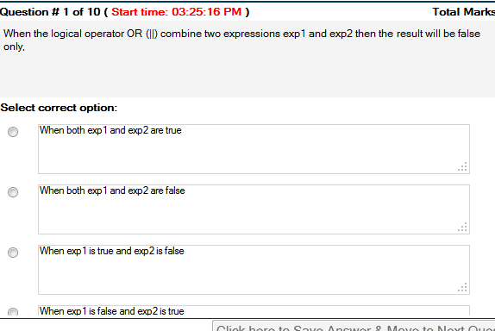
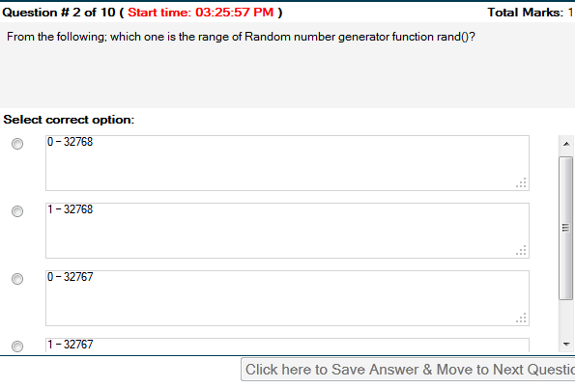
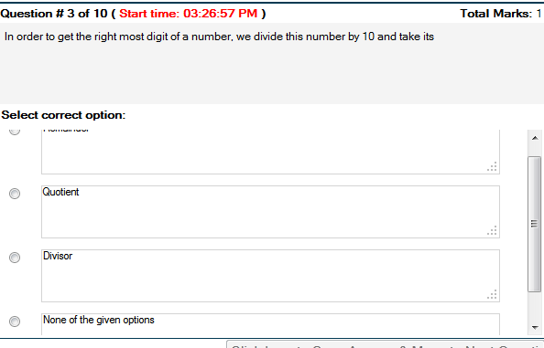
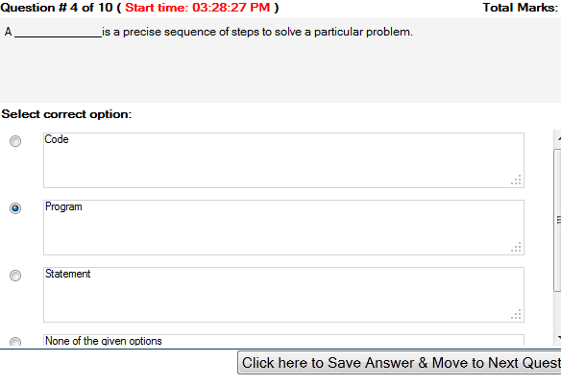

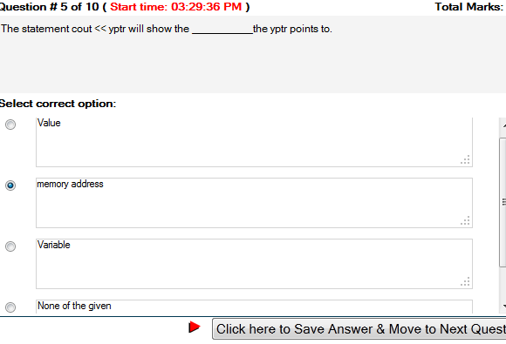
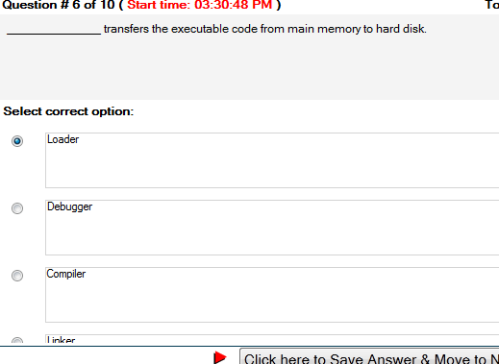

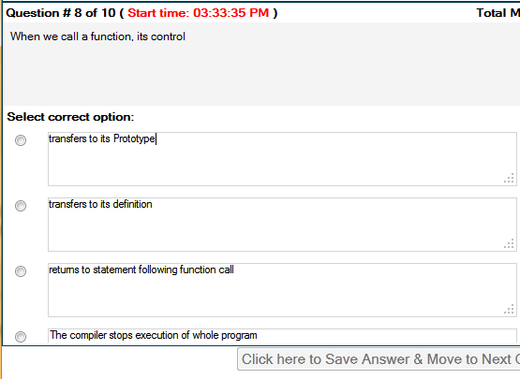
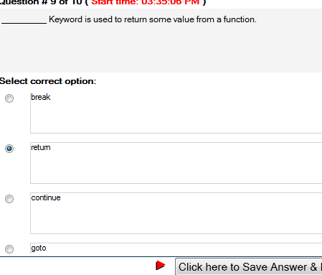
Not sure
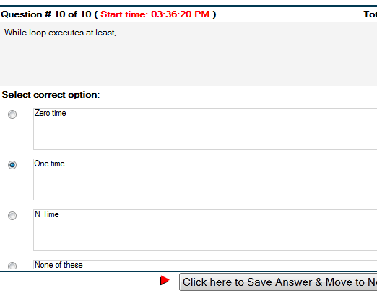

CS201 Introduction To Programming Solved MCQs from Quiz 2 November 30, 2013

Functions declared with the _______________ specifier in a class member list are called friend functions of that class.
protected
private
public
friend
Functions declared with the friend specifier in a class member list are called friend functions of that class. Classes declared with the friend specifier in the member list of another class are called friend classes of that class.
Public or private keywords can be ____________
written only for once in the class or structure declaration
written multiple times in the class or structure declaration
written only twice in the class declaration
written outside the class
good practice is to write public or private keywords only once in the class or structure declaration, though there is no syntactical or logical problem in writing them multiple times.
The friend keyword provides access _____________.
in one direction only
in two directions
to all classes
to the data members of the friend class only
The friend keyword provides access in one direction only. This means that while OtherClass is a friend of ClassOne, the reverse is not true.
References cannot be uninitialized. Because it is impossible to _______________
reinitialize a pointer
reinitialize a reference
initialize a NULL pointer
cast a pointer
References cannot be uninitialized. Because it is impossible to reinitialize a reference,
new operator can be used for ______________.
only integer data type
only char and integer data types
integer , float, char and double data types
dot operator
Similarly, new operator can be used for other data types like char, float and double etc.
The destructor is used to ______________.
allocate memory
deallocate memory
create objects
allocate static memory
Reference is not really an address it is ______________.
a synonym
an antonym
a value
a number
Difference Between References and Pointers
The reference in a way keeps the address of the data entity. But it is not really an address it is a synonym,
If we want to allocate memory to an array of 5 integers dynamically, the syntax will be _____________.
int *iptr ; iptr = new int[5] ;
integer iptr** ; iptr= new int[5]
int iptr ; iptr= int [5]
iptr= new[5]
Memory allocated from heap or free store _____________________.
can be returned back to the system automatically
can be allocated to classes only
cannot be returned back unless freed explicitly using malloc and realloc
cannot be returned back unless freed explicitly using free and delete operators
The memory allocated from free store or heap is a system resource and is not returned back to the system unless explicitly freed using deleteor free operators.
Operator overloading is to allow the same operator to be bound to more than one implementation, depending on the types of the _________.
Compilers
Operands
Function names
Applications
Operator overloading is to allow the same operator to be bound to more than one implementation, depending on the types of the operands.
The operator to free the allocated memory using new operator is ________________.
free
del
delete
remove
The operator to free the allocated memory using new operator is delete. So whenever, we use new to allocate memory, it will be necessary to make use of ‘delete’ to deallocate the allocated memor

My CS201 Solved Quiz No.2. 2013
Question # 1 of 10 ( Start time: 02:17:54 PM ) Total Marks: 1
By default, the starting index of an array in C++ is _______.
Select correct option:
2
-1
0
1

Question # 2 of 10 ( Start time: 02:19:01 PM ) Total Marks: 1
We can define a matrix as__________ array.
Select correct option:
Sorted
Unsorted
Single dimensional
Multi dimensional
Question # 3 of 10 ( Start time: 02:19:52 PM ) Total Marks: 1
We can access a global variable ___________
Select correct option:
From the functions only
From the loops only
From the main() function only
From anywhere in the program

Question # 4 of 10 ( Start time: 02:21:00 PM ) Total Marks: 1
A function’s prototype is written __________the function call.
Select correct option:
After
Before
With
At the end of

Question # 5 of 10 ( Start time: 02:22:23 PM ) Total Marks: 1
Which of the function call is call by value for the following function prototype? float add(int);
Select correct option:
add(&x);
add(x);
add(int x);
add(*x);

Question # 6 of 10 ( Start time: 02:23:22 PM ) Total Marks: 1
+= , *= , /= , etc are called,
Select correct option:
Assignment operators
Logical operator
Compound assignment operator
Unary operator

Question # 7 of 10 ( Start time: 02:24:02 PM ) Total Marks: 1
What is the output of the following code if the 2nd case is true switch (var) { case ‘a’: cout”apple”endl; case ‘b’: cout”banana”endl; case ‘m’: cout”mango”endl; default: cout”any fruit”endl; }
Select correct option:
banana
banana any fruit
banana mango anyfruit
none of the above

Question # 8 of 10 ( Start time: 02:25:00 PM ) Total Marks: 1
In C/C++, by default arguments are passed by _______ to a function.
Select correct option:
Reference
Value
Size
Data

Question # 9 of 10 ( Start time: 02:25:19 PM ) Total Marks: 1
What will be the value of ‘a’ and ‘b’ after executing the following statements? int a = 9; int b = a++; cout/p>
Select correct option:
10,9
9,10
9,9
10,10

Question # 10 of 10 ( Start time: 02:26:43 PM ) Total Marks: 1
What is the output of the following code if the 3rd case is true switch (var) { case ‘a’: cout”apple”endl; case ‘b’: cout”banana”endl; case ‘m’: cout”mango”endl; default: cout”any fruit”endl; }
Select correct option:
mango
mango any fruit
apple
none of the above

CS201 Quiz No 2 December 3, 2013

__________ operator is used to pass the address of a variable in call by reference method.
&
In C++, what will be the highest index of the following array? int array[15];
15
For breaking complex problems into smaller pieces we use _______.
Functions
Function prototype is written,
Before the return statement in main
When we call a function, its control
The compiler stops execution of whole program
+= , *= , /= , etc are called,
Compound assignment operator
What will be the result of the expression k = ++m; if initially k = 0 and m = 5?
0
By default, the starting index of an array in C++ is _______.
0
What will be the size of the following character array? char name[] = “Adeel”;
5
_________statement is used to terminate the processing of a particular case and exit from switch structure.
continue

Quiz No. 02 Fall 2013

