Solved by
HIRA AFTAB , MIKE ALI, CHULBULI TITLI

1-Difference b/w branch and structural hazards.(5 marks)
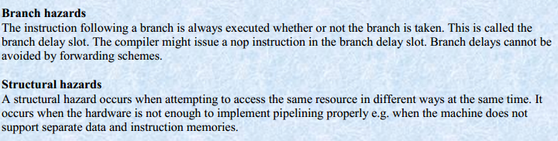

Which technique is used for overlapping multiple instructions in time? (2 marks)
Ans:
Pipeline technique is used for overlapping multiple instructions in time
3-Write any two stages of designing and implementation phase of pipelining (2 marks)
1. Adapting the instructions to pipelined execution
2. Designing the pipelined data
- Generating control signals Control signals

5-SRC five-stage pipeline. arranged them,These stages were given.Those five stages are given below:
1. Instruction Fetch
2. Instruction decode/operand fetch
3. ALU operation
4. Memory access
5. Register write
- Explain horizontal and vertical microcode? (3 marks)
Ans;
Horizontal and vertical microcode schemes
In horizontal microcode schemes, there are no intermediate decoders and the control word bits are directly connected to their destination i.e. each bit in the control word is directly connected to some control signal and the total number of bits in the control word is equal to the total number of control signals in the CPU. Vertical microcode schemes employ an extra level of decoding to reduce the control word width. From an n bit control word we may have 2n bit signal values. However, a completely vertical scheme is not feasible because of the high degree of fan out.
3. Write the structure RTL description for out instruction i.e out ra, c2. 3 Marks
Write the two ways to increase the number of instruction in a given time by the processor? Explain each one briefly?5 Marks
Ans:
There are two ways to increase the number of instructions executed in a given time by a processor
By increasing clock speed
By increasing number of instructions that can execute in parallel
Increasing the clock speed
• Increasing the clock speed is an IC design issue and depends on the advancements in chip technology.
• The computer architect or logic designer cannot thus manipulate clock speeds to increase the throughput of the processor.
Increasing parallel execution of instructions
The computer architect cannot increase the clock speed of a microprocessor however he/she can increase the number of instructions processed per unit time. In pipelining we discussed that a number of instructions are executed in a staggered fashion, i.e. various instructions are simultaneously executing in different segments of the pipeline. Taking this concept a step further we have multiple data paths hence multiple pipelines can execute simultaneously.
Explain [c←A+c2(sign extend)] ( 2 marks )
In this step we would add the constant c2 after sign extension to the contents of temporary register A. As a result we would have the effective address in the buffer register C, to which we need to jump.
Write any three stages of designing and implementation phase of pipelining ( 3 marks )
Adapting the instructions to pipelined execution
Designing the pipelined data path
Generating control signals
Dif b/w PC and IR ( 3marks )
Two special registers, the Program Counter (PC) and the Instruction Register (IR). PC points to the next instruction to be executed, and the IR holds the current instruction.
Describe the working of a general micro-coded controller? (3)
Ans:
Working of a general microcoded controller
A microcoded controller works in the same way as a small general purpose computer.
1. Fetch a micro-instruction and increment micro-PC.
2. Execute the instruction present in micro-IR.
3. Fetch the next instruction and so on…
Write name of all the registers used in the task of pipe lining? (5)
Ans:
IR2,IR3,IR4,IR5,PC2,X3,Y3,Z4,Z5,MD3,MD4
RTL for Jz ra (c2) ( 5 marks )
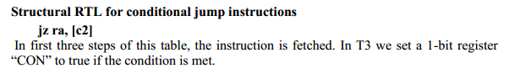
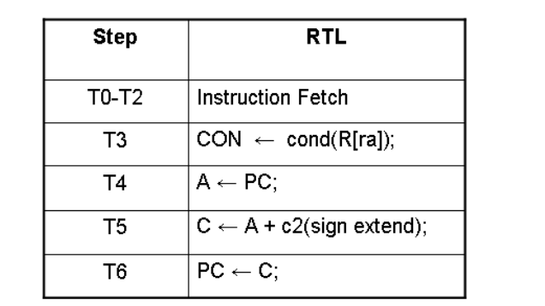
Question 2: what is the functionality of LMBR control signal in SRC ? (2)
LMBR: This enables the "write" for the register MBR. When this signal is activated, whatever value is on the bus, can be written into the MBR

Structured RTL for add operation? (5)
Structural RTL for addition instruction add ra, rb, rc The table of add instruction is almost same as of sub instruction except in timing step T4 we have + sign for addition instead of – sign as in sub instruction. Other instructions that belong to the same group are „and‟, „or‟ and „sub‟.
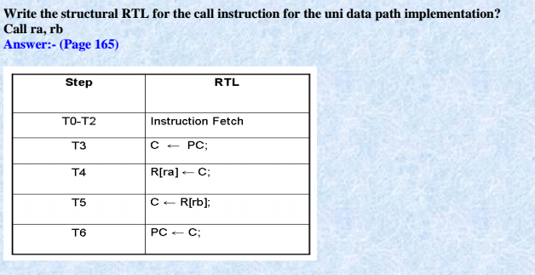
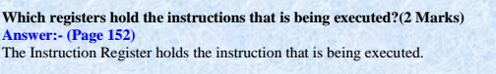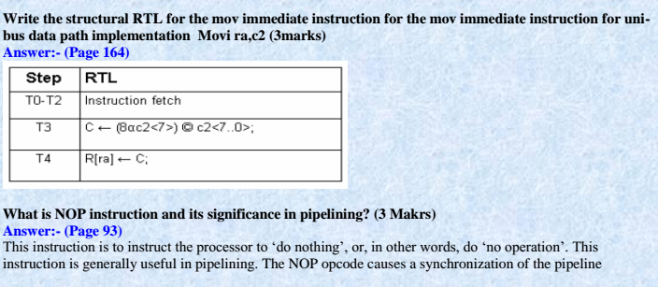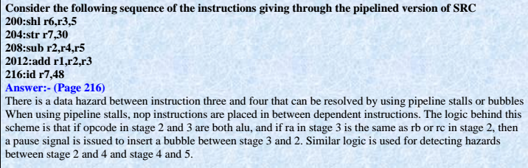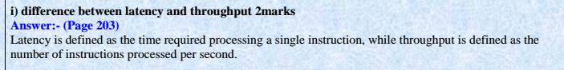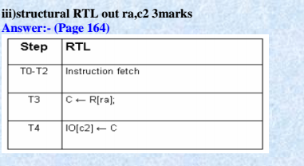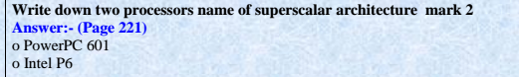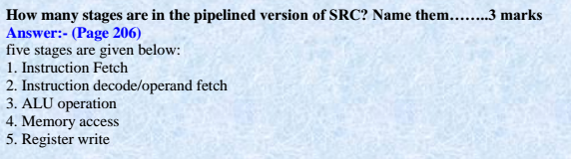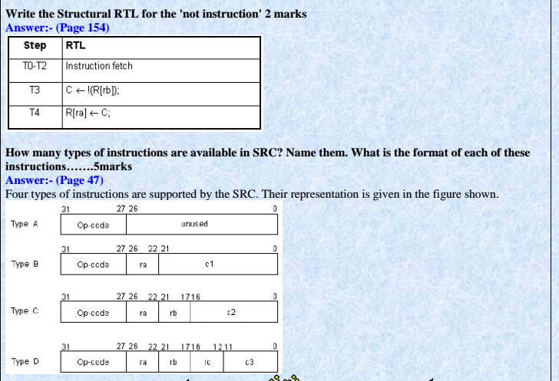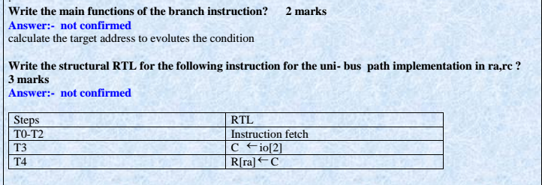

2-Which registers are used in every steps of pipelining ( 5 marks )
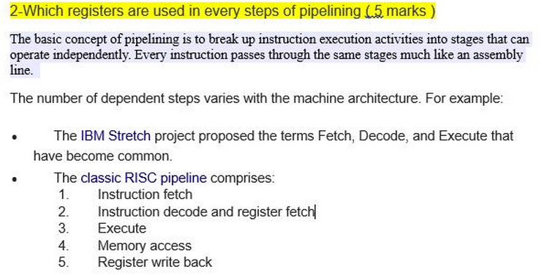

Structured RTL for "mov" ra, rb? (3)

