Solved by
MIKE ALI, HIRA AFTAB , CHULBULI TITLI
Question No: 27 ( Marks: 2 )
Diffrentiate between Regular and Non regular languages?
Ans:The main difference between regular and non regular language are as:
1. The regular language is that language which can be expressed by RE is known as regular language whereas any language which can not be expressed by RE is known as non regular language.
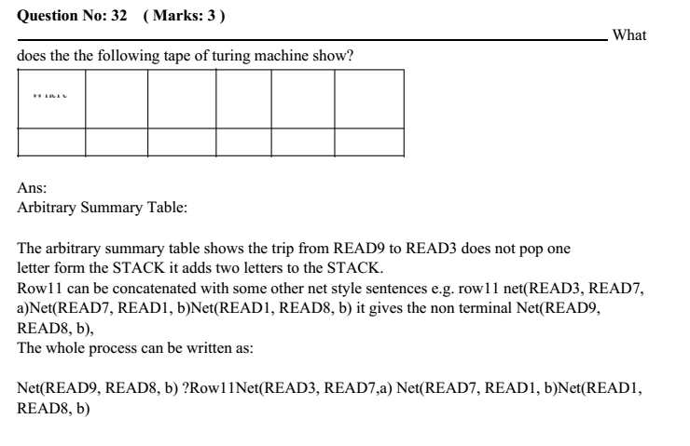
Question No: 29 ( Marks: 2 )
What are the halt states of PDAs?
Ans:
There are some halts states in PDA which are as:
Accept or reject stat is also halt state.
Reject state is like dead non final state.
Accept state is like final state.
Question No: 36 ( Marks: 5 )
What are the conditions (any five) that must be met to know that PDA is in conversion form?
Ans:
Conversion form of PDA:
A PDA is in conversion form if it has following conditions:
1. The PDA must begin with the sequence
2. There is only one ACCEPT state.
3. Every edge leading out of any READ or HERE state goes directly into a POP state.
4. There are no REJECT states.
5. All branching, deterministic or nondeterministic occurs at READ or HERE states.
6. The STACK is never popped beneath this $ symbol.
7. No two POPs exist in a row on the same path without a READ or HERE.
8. Right before entering ACCEPT this symbol is popped out and left.
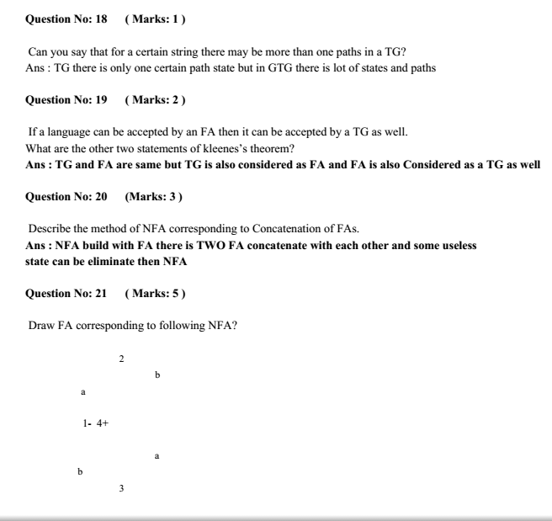
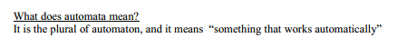

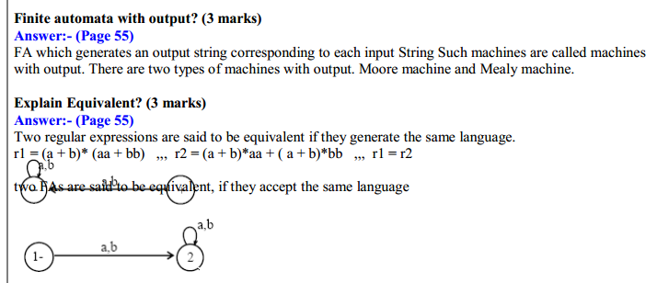
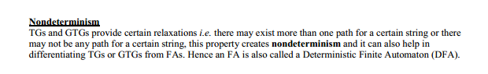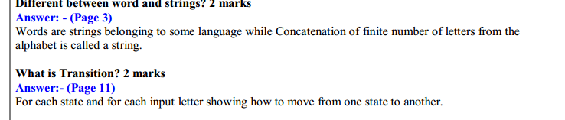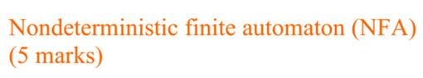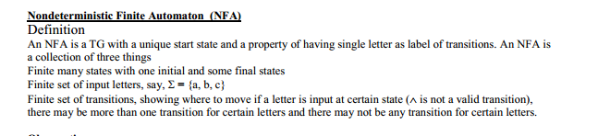

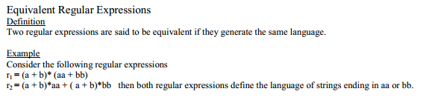
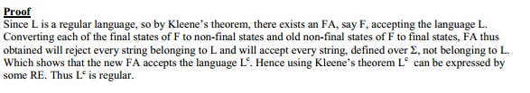
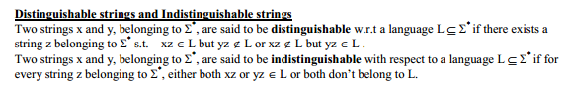

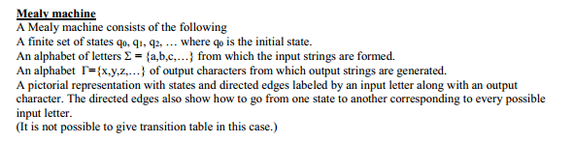
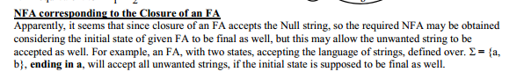
Chapter 6





