Mobi Quiz

Software Requirements Specification

Version 1.1



Group Id: S1302B9CE7
Supervisor Name: Sarfraz Ahmad Awan

Revision History

Date  (dd/mm/yyyy) | Version | Description | Author
18/06/2013 | 1.0 | The project will focus on developing a web application that will deals with the concept to solve quiz on mobile phone. | Mc110402675

Table of Contents

- Scope (of the project)
- Functional Requirements Non Functional requirements
- Use Case Diagram
- Usage Scenarios

Scope of Project:

The project will focus on developing a web application that will deals with the concept to solve quiz on mobile phone by using an application. The user will be log in to mobile application by providing login credentials like password and mobile number. The application will be able to provide the ability to solve quiz online by using the student’s personal GSM mobile phone. The application will create questions relevant to the subject and on lecture based. It can also Create Quiz by using existing questions. It will also publish result to the students. Result will be published in student’s account and SMS will also be sent to the students. It will also View grade book and current registered courses.

Functional and non Functional Requirements:

Functional Requirements:

Following are the detailed Functional requirements for this project:
- The user will be log in to his mobile phone (GSM mobile) for solving or submitting his quiz
- There should be proper management of login credentials for different students like student mobile number and password.
- In this application, the Administrator User should be able to deals with User Management, Faculty Management, Course Management, Student Management, Degree program management.
- In this application, The Administrator User should be able to Assign Course,
- In this application, The Administrator User should be able to Add new Semester in the application, ,
- In this application, The Administrator User should be able to Enroll/add students to the course in particular semester of degree program.
- In this application, the faculty member of the environment will be able to create question, create quiz, set flags with each quiz, view question, view students and publish results.
- In this application, the student can View grade book and current registered courses.
- In this application, The student can View history of Quiz and results
- In this application, student can login using its mobile or online interface.
- In this application, student can send request to start paper using SMS.
- In this application, Students can answer MCQs using SMS.

Non-Functional Requirements:

Accessibility:
Accessibility can be viewed as the "ability to access”. This software should have a reliable access method.

Privacy:
In this application, Privacy will be an important issue as it will permit to solve quiz to only valid user. This validation will be checked through student’s mobile number and password.

Efficiency:
This application will be very efficient as it will facilitate users to access his account and solve quiz by any source of internet in mobile phones GSM mobile.

User friendly display:
In this application, the atmosphere will be user friendly. The students can access his account very easily and solve his quiz with in no time and can see quiz in an easy way. Succession in solving and submitting the quiz will also be shown.

Reliability:
In this application, reliability will also be taken into consideration. If a student with wrong password can want to get access, it will not permit to access his account.

Use Case Diagram

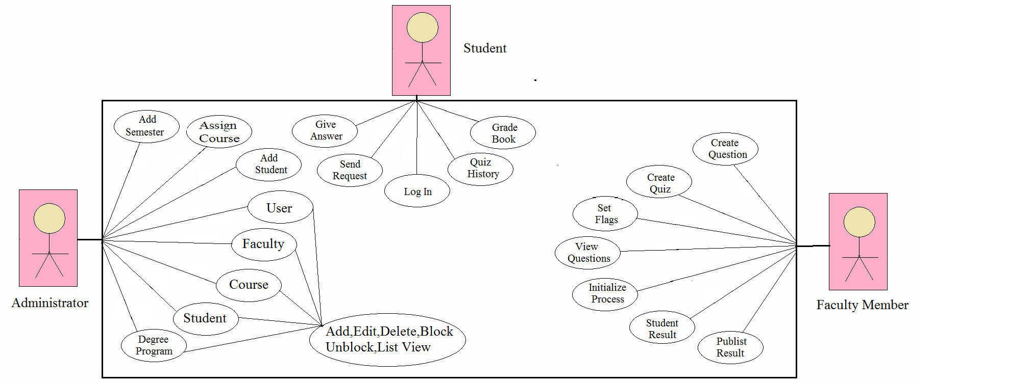

Usage scenarios:

Use Case Title | Signup in the system
Use Case Id | 1
Requirement Id | 1
Description:
This use case is about Student name and pwd for registration in the system

Pre Conditions:
  - All must-required information about the user should be available.
Task Sequence |  | Exceptions
- open registration form
- fill the form |  | Error in database
- provide complete information
4. Server didn’t recognize only numeric or alphabetic
5. system sends the message in case of success
Post Conditions: User has successfully registered in the system
Unresolved issues:
Authority: Student
Modification history: 1.0
Author: MC12345567

Use Case Title | Login in the system
Use Case Id | 2
Requirement Id | 2
Description:
The user will login in the system. The student will have to provide his cell no and password for logging in. Password should be containing only numeric and symbol.
Pre Conditions:
User has registered in the system
Task Sequence |  | Exceptions
1. To login server require a valid password |  | Error in database
2. user provides cell number and pwd
3. user logins successfully
Post Conditions: user has successfully login in the system
Unresolved issues:
Authority: Student
Modification history: 1.0
Author: MC12345567

Use Case Title | Solve Quiz
Use Case Id | 3
Requirement Id | 3
Description:
This use case is about solving the quiz online by using the student personal mobile.
Pre Conditions:
User has login in the system
Task Sequence |  | Exceptions
1. The student will open quiz. |  | Error in internet
2. The student will solve the quiz.
3. The user will save the quiz successfully.
Post Conditions:
Quiz has finished successfully
Unresolved issues:
Authority: user
Modification history: 1.0
Author: MC12345567

Use Case Title | Check history of quiz
Use Case Id | 4
Requirement Id | 4
Description:
In this use case the user will be able to check the history of quiz.
Pre Conditions:
User has login in the system
Task Sequence |  | Exceptions
1. Click on the quiz history tab. |  | No record found
2. Open quiz history.
3. Check and Read quiz history
4 user can also cancel the downloading of the file
Post Conditions:
User has checked the history of quiz successfully
Unresolved issues:
Authority: Student
Modification history:1.0
Author: MC12345567

Use Case Title | Enroll and Add Student
Use Case Id | 5
Requirement Id | 5
Description:
In this use case the administrator user will add or enroll the new student in the database of student.
Pre Conditions:
The user has login in the system
Task Sequence |  | Exceptions
1. Check the availability of the user. |  | Error in adding the new student
2. Enter details of the new user that is being enrolled.
3. Save the details of the new student
Post Conditions:
New Student has added and enrolled successfully
Unresolved issues:
Authority: Administrator
Modification history: 1.0
Author: MC12345567

