MIDTERM EXAMINATION
Fall 2011
MTH302- Business Mathematics &amp; Statistics (Session - 2)

Question No: 1 ( Marks: 1 ) - Please choose one
Store A marked down a $ 50 perfume to $ 40 with markdown of $10
The % Markdown is

► 10%

► 20%
► 30%

► 40%

Question No: 2 ( Marks: 1 ) - Please choose one
Given Net price of shirt = $20 , Discount = 10% ,List price will
► $22
► $24
► $26
► $30

Question No: 3 ( Marks: 1 ) - Please choose one
Which is the correct syntax for the determinant of a matrix given by the following array
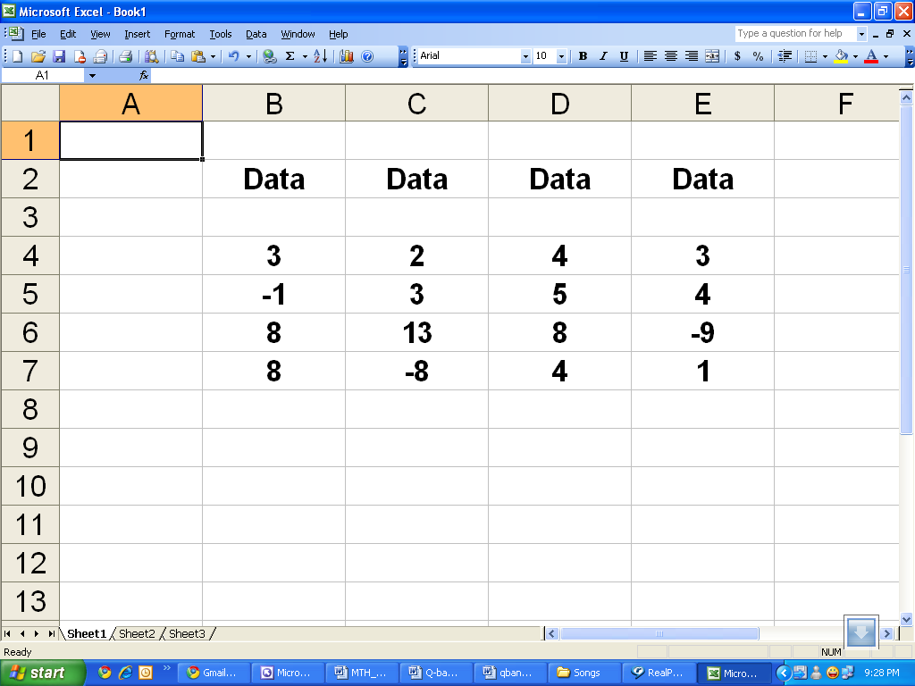

► =DETERM(B4:E7)

► =MDTERM(B4:E7)

► =MDETERM(B4:E7)

► =MDETERM(B4;E7)

Question No: 4 ( Marks: 1 ) - Please choose one
VDB returns the depreciation of an asset for

► Zero period

► One period

► Two period

► Any arbitrary period

Question No: 5 ( Marks: 1 ) - Please choose one
If the cost & selling price of a pen are Rs.12 & Rs.15 respectively, profit percentage is:

► 33.33%

► 25%

► 20%

► 10%

Question No: 6 ( Marks: 1 ) - Please choose one
This example returns the depreciation for an asset that costs Rs. 10,000, with a salvage value of $8,000. The useful life of the asset is 5 years. The depreciation is being calculated for the third year, and there are 10 months in the first year.
► =DB (10000, 5, 8000, 3, 10)
► =DB (10000, 8000, 5, 10, 3)
► =DB (10000, 8000, 5, 3, 10)
► =DB (10000, 8000, 10, 3, 5)

Question No: 7 ( Marks: 1 ) - Please choose one
Which of the following functions is not related to financial analysis?
► AMORDEGRC
► AMORLINC
► CUMIPMT
► MDETERM

Question No: 8 ( Marks: 1 ) - Please choose one
(2) ^ -2 = ) 0.25……..

► 
► 
► 
► 

Question No: 9 ( Marks: 1 ) - Please choose one
 Dimension of a matrix means
       ► Column space

       ► Row space

       ► Order of the matrix

       ► None of these

Question No: 10 ( Marks: 1 ) - Please choose one
 
If there is a -30% change in the price of an item, what does the negative sign show?
       ► The price is increasing.
       ► The price is decreasing.
       ► The price has low rate of change.
       ► None of the above.

Question No: 11 ( Marks: 1 ) - Please choose one
 According to taxation rules; the amount of allowances is treated tax free if it is upto 50% of the basic salary.

       ►
       ►
       ► 
       ►

Question No: 12 ( Marks: 1 ) - Please choose one
 Write a formula to find the simple interest (I) if $5000 is invested at 4% for 2 years.
       ► I=PRT
       ► I=P+R+T
       ► I=PT
       ► I=P(R+T)

Question No: 13 ( Marks: 1 ) - Please choose one
 Every percentage can be converted into:
       ► Decimal
       ► Ratio

       ► Proportion
       ► Both decimal & ratio

Question No: 14 ( Marks: 1 ) - Please choose one
Monthly installments of a leased car are calculated by using the techniques of:
► Simple interest method

► Compound interest method

► Annuity
► Hit & trial method

Question No: 15 ( Marks: 1 ) - Please choose one
Suppose that you are spending 1500 dollars in an investment and Accumulated factor is 15 then Accumulated Value will be
► 22550
► 22500
► 21000
► 22510

Question No: 16 ( Marks: 1 ) - Please choose one
What is the interest on Rs. 1600 for one year at the rate %?
► 65
► 56
► 75
► 90

Question No: 17 ( Marks: 2 )
A man borrows $39000 for 1and half year at a rate of 1.65%. What is the simple interest he has to pay?
Simple interest is given by
I= P*R*T/100
P= principal = $39000
R= interest rate= 1.65%
T= 1.5 year
Interest, I =(39000 * 1.65 *1.5)/100 = Rs 965.25

Question No: 18 ( Marks: 2 )
If
Cost price = 2000Rs
Selling price = 6500Rs
Then what will be %Markup on cost?

MUC= S- C (Rs markup on cost = selling price- cost price)
= 6500-2000 = Rs 4500
% markup on cost = (MuC/cost price) * 100 = (4500/2000) *100= 225%

Question No: 19 ( Marks: 3 )

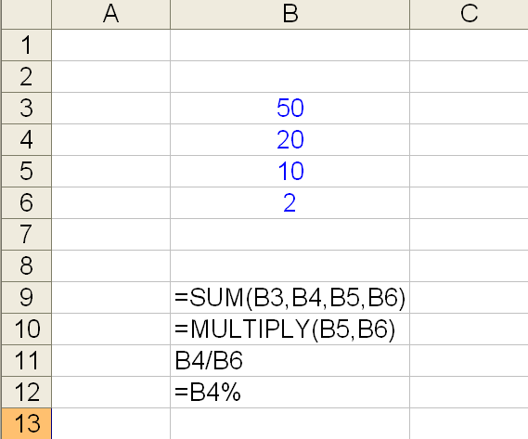

Write the output of B9, B10, B11 and B12. If you think the formula is incorrect write "Error" in output.

ANSWER:
The output of =sum(B3,B4,B5,B6) = 100

=multiply(B5,B6) will not give result because multiply is not a excel function

B4/B6 is not a formula because in excel formula must start with "="

=B4% will return 0.2

Question No: 20 ( Marks: 5 )
A gold chain is sold for Rs. 6500 at a gain of 25%. Find the profit.

Selling price = 6500
Profit = 25%
Profit in Rs= (6500*25)/100= Rs 1625

Question No: 21 ( Marks: 10 )
For the following matrices perform the indicated operation, if possible.
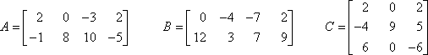
(a)
(b)
(c)
a)
A = 2 0 -3 2 + B = 0 -4 -7 2
-1 8 10 -5 12 3 7 9

A+B= 2+0 0-4 -3-7 2+2
-1+12 8+3 10+7 -5+9

A+B = 2 -4 -10 4
11 11 17 4

b)
B-A= 0-2 -4-0 -7-(-3) 2-2
12-(-1) 3-8 7-10 9-(-5)

B-A= -2 -4 -4 0
13 -5 -3 14
c) A+C is not conformable for addition because for addition number of rows and columns of A must be equal to number of rows and columns of C

