FINALTERM EXAMINATION
Spring 2009
MTH302- Business Mathematics &amp; Statistics (Session - 1)
Time: 120 min

Question No: 1 ( Marks: 1 ) - Please choose one
In scatter diagram if both variables X and Y tend to move in the same direction the correlation is called

► Negative

► No Correlation

► Curvilinear

► Positive

Question No: 2 ( Marks: 1 ) - Please choose one
In EXCEL use the …………….function to calculate correlation

► COREL

► CORREL
► CORRELE

► CORRELATION

Question No: 3 ( Marks: 1 ) - Please choose one
Slope of the line passing through the points A (2, 3) and B (3, 4) is

► Zero

► One
► Two

► Three

Question No: 4 ( Marks: 1 ) - Please choose one
The equation for the intercept of the regression line is where b is

► Intercept

► Slope
► Equation

► Dependant variable

Question No: 5 ( Marks: 1 ) - Please choose one
The correlation coefficient between x and y shows
► Whether y depends on x
► whether x causes y
► whether there is any relation between x and y
► whether there is a linear relation between x and y

Question No: 6 ( Marks: 1 ) - Please choose one
In a linear regression of y on x, y = a + bx,
► the variance of x is constant for all values of y
► a fitted straight line goes through (0, 0)
► Both variables have the same variance
► x is the explanatory variable

Question No: 7 ( Marks: 1 ) - Please choose one
Equation for the line having slope 5 and intercept 3 is

►
►
►
►

Question No: 8 ( Marks: 1 ) - Please choose one
As the relationship deteriorates from a perfect correlation, what happens to the points on a scatter diagram?

► They become more scattered.
► The slope changes.

► The y-intercept changes.
► Both (ii) and (iii), above.

Question No: 9 ( Marks: 1 ) - Please choose one
The measure of how well the regression line fits the data is the:
► coefficient of determination
► slope of the regression line
► mean square error
► standard error of the regression coefficient

Question No: 10 ( Marks: 1 ) - Please choose one
How many arrangements can be made of the letter MOVING

► 900
► 120
► 600
► 720

Question No: 11 ( Marks: 1 ) - Please choose one
The method of moving averages is used for what purposes?
► It is used to plot a series.
► It is used to exponentiate a series.

► It is used to smooth a series.

► It is used in regression analysis.

Question No: 12 ( Marks: 1 ) - Please choose one
In a set of 10 observations the mean is 20 and the median is 15. There are 2 values that are 6, and all other values are different. What is the mode?
► 15
► 20
► 6
► 16

Question No: 13 ( Marks: 1 ) - Please choose one
If sign of r is negative then it indicates
► Direct relationship between X & Y

► Indirect relationship between X & Y
► X & Y equal
► X & Y are square

Question No: 14 ( Marks: 1 ) - Please choose one
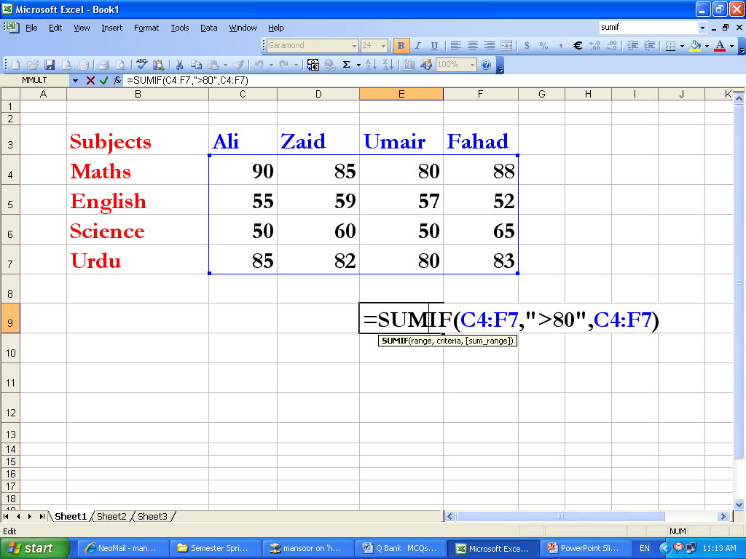

The answer of the SUMIF function in the above diagram is:
► 763
► 663
► 613
► 513

Question No: 15 ( Marks: 1 ) - Please choose one
In a class of 30 students, there are 17 girls and 13 boys. Five are A students, and three of these students are girls. If a student is chosen at random, what is the probability of choosing a girl or an A student?
► 19/30
► 11/15
► 17/36
► None of these

Question No: 16 ( Marks: 1 ) - Please choose one
If an event has an even chance of happening it has a probability of 2
► True

► False

Question No: 17 ( Marks: 1 ) - Please choose one
The formula for the standard deviation for population is
►
►
►
► None of the above

Question No: 18 ( Marks: 1 ) - Please choose one
Men tend to marry women who are slightly younger than themselves.
Suppose that every man married a woman who was exactly .5 of a year
younger than themselves. Which of the following is CORRECT?

► The correlation is −.5.
► The correlation is .5.
► The correlation is 1.
► The correlation is −1.
► The correlation is 0

Question No: 19 ( Marks: 1 ) - Please choose one
Three year moving averages is
► Arithmetic mean of 3 numbers continuously.
► Sum of 3 numbers continuously.
► Average of 3 fixed numbers.
► Sum of 3 fixed numbers.

Question No: 20 ( Marks: 1 ) - Please choose one
The price at which the product should be sold to the consumer is called the _______ price.
► Retailer’s

► List
► Manufacture’s

► Raw material

Question No: 21 ( Marks: 1 ) - Please choose one
If A and B are any two matrices of order and respectively and m>n and p<q. What should be the condition on m, n, p, q for the product AB to hold?

► n>p
► m<=q
► q=p
► n=p

Question No: 22 ( Marks: 1 ) - Please choose one
According to taxation rules; the amount of allowances is treated tax free if it is upto of the basic salary.

► Half of
► One third
► 40%
► One fourth

Question No: 23 ( Marks: 1 ) - Please choose one
The minimum number of points required to calculate the intercept of a straight line is/are
► one
► two
► three
► one or theree

Question No: 24 ( Marks: 1 ) - Please choose one
The price of a fountain pen was Rs.15 which grew to Rs. 19.50. Find the percent change.
► 3%
► 0.3%
► 30%
► 0.03%

Question No: 25 ( Marks: 1 ) - Please choose one
Ali has improved his typing speed from 40w/m to 60w/m.The percentage improvement is
Answer is 33.33%
( I could note read the choice due to some special character in options) instead of number

       ► 
       ► 
       ► 
       ► 

Question No: 26 ( Marks: 1 ) - Please choose one
This example returns the depreciation for an asset that costs Rs. 10,000, with a salvage value of $6,000. The useful life of the asset is 4 years. The depreciation is being calculated for the first year, and there are 12 months in the first year.

       ► =DB (10000, 6000, 4, 1, 12)
       ► =DB (10000, 6000, 4, 12, 1)
       ► =DB (6000, 10000, 4, 12, 1)
       ► =DB (10000, 6000, 4, 1, 1)

Question No: 27 ( Marks: 1 ) - Please choose one
This example returns the depreciation for an asset that costs Rs. 10,000, with a salvage value of $8,000. The useful life of the asset is 5 years. The depreciation is being calculated for the third year, and there are 10 months in the first year.
       ► =DB (10000, 5, 8000, 3, 10)
       ► =DB (10000, 8000, 5, 10, 3)
       ► =DB (10000, 8000, 5, 3, 10)
       ► =DB (10000, 8000, 10, 3, 5)

Question No: 28 ( Marks: 1 ) - Please choose one
To add two cells (A1 and A2) together you use the following formula

       ►  =A1 + A2
       ► =Add(A1+A2)
       ► =together(A1:A2)
       ► A1 plus A2

Question No: 29 ( Marks: 1 ) - Please choose one
If ratio of boys and girls in a class is 7: 5, which of the following can’t be the total number of the students in the class?

       ► 36

       ► 50

       ► 60

       ► 120

Question No: 30 ( Marks: 1 ) - Please choose one
Assume you will work for the next 20 years and at the end of each year you will deposit $20,000 into a savings account. At the end of that 20 year period you will start withdrawing your retirement living expenses from that account at the beginning of every year. This financial plan involves a _____ problem while you are working and a _____ problem while you are in retirement.
       ► a present value of a dollar, future value of a dollar
       ► a future value of an annuity due, a present value of an annuity due
       ► a future value of an annuity due, a present value of an ordinary annuity
       ► a future value of an ordinary annuity, a present value of an annuity due
       ► a future value of an ordinary annuity, a present value of an ordinary annuity

Question No: 31 ( Marks: 1 ) - Please choose one
which of the following is linear equation

       ► 2x-3y=-6

       ► x+x+x

       ► 520x²y²

       ► y^2 -3=0

Question No: 32 ( Marks: 1 ) - Please choose one
For graphing univariate data we use

       ► Pie charts,Bar charts .

       ► Pareto diagrams.

       ► Side by side chart .

       ► Both (1) & (2)

Question No: 33 ( Marks: 1 ) - Please choose one
If an operation A can be performed in m ways and B in n ways, then the two operations can be performed together in ------ways.
       ► m+n
       ► m-n
       ► m*n
       ► n/m

Question No: 34 ( Marks: 1 ) - Please choose one
---
► 100

► 0

► 1
► None of these

Question No: 35 ( Marks: 1 ) - Please choose one
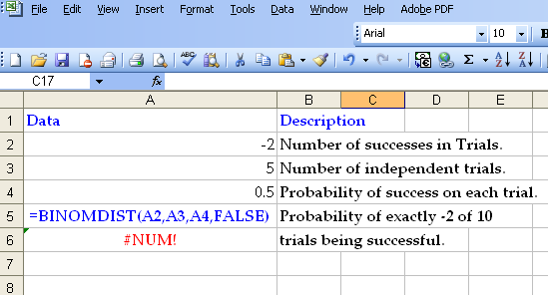

The result of BINOMDIST is #NUM. Why?

► One parameter is missing.
► Third parameter is FALSE
► The number of successes in trials is negative.
► Probability of success on each trial is not suitable.

Question No: 36 ( Marks: 1 ) - Please choose one
For a Poisson random variable, the probability that X is some value x is given by the following formula:

►
► b*(x; r, P) = _{x-1}C_{r-1} * P^{r} * (1 - P)^{x - r}
►
► None of the above.

Question No: 37 ( Marks: 1 ) - Please choose one
In the formula, 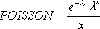, e is a constant whose value is ……………

► 2.71828
► 3.14157
► 22 / 7
► 9.325

Question No: 38 ( Marks: 1 ) - Please choose one
Time series data is analyzed by the moving average.

► True
► False

Question No: 39 ( Marks: 1 ) - Please choose one
The Linear Programming Model maximize or minimize the = Linear Function

► 
► both linear and quadratic functions
► 
► 

Question No: 40 ( Marks: 1 ) - Please choose one
Is every Linear Programming has solution?

(Again options are not readable in this question)

       ►
       ► false
       ► may or may not
       ►

Question No: 41 ( Marks: 2 )
A student is chosen at random from a class of 16 girls
and 14 boys. What is the probability that the student
chosen is not a girl?

Solution:
Total boys + girls = 14+16 = 30
p( student is boy) = 14/30 = 7/15

Question No: 42 ( Marks: 2 )
Write down the formula for Poisson distribution.( Not Excel formula )
Just as with the binomial distribution there is a formula for calculating probabilities

Solution
f (x) =( mean of number of successes in a given time period)^x . e / x!

e=2.71828

Question No: 43 ( Marks: 2 )
What will be the correlation coefficient r between variables X and Y if varX=4,varY=9 and Cov(X,Y)=3 ?

Solution:

Question No: 44 ( Marks: 3 )
Suppose we draw a card from a deck of playing cards. What is the probability that we draw a spade?

Solution:

Total spade cards = 13
Total cards in deck = 52
P(card of spade) = 13/52 = 1/4

Question No: 45 ( Marks: 3 )
Find the range and median of the following set of data 1,2,5,7,5,2,5,2,2,6,9,8,7,1,5.

Solution:

To get median sorting
1 | 1 | 2 | 2 | 2 | 2 | 5 | 5 | 5 | 5 | 6 | 7 | 7 | 8 | 9

Median = 5 and 2
Range = highest value – lowest value
= 9-1 = 8

Question No: 46 ( Marks: 3 )
If a pollster might want to know whether or not, say, the sex, the ethnic background or salary range of a person is factor in his or her vote in election or for some type of legislation then justify which distribution is best fit for this scenario?(least two sentence description )

Solution:

We prefer Normal Distribution over others due to following

It is applied in situations where data is widely distributed. We use Normal distribution on sample data to get a better picture of large data which is not possible to collect in real life like population, scientific research data etc. because normal distributions are much easier to analyze.

The normal distribution can be used to describe, at least approximately, any variable that gathered near the mean In simple terms the Normal distribution is useful for study of real world distributions because in the real world a single distribution (like height of men) is a result of other random factors. In normal distribution we can calculate indefinite number of data.

Question No: 47 ( Marks: 5 )
Find all the quartiles for the following data set:
77, 79, 80, 86, 87, 87, 94, 99

Solution:

77 | 79 | 80 | 86 | 87 | 87 | 94 | 99

Question No: 48 ( Marks: 5 )
Calculate number of ways, a committee of 3 people comprising the President, Secretary and Treasurer to chosen from 8 possible candidates.

Solution:

Question No: 49 ( Marks: 5 )
If X is a Poisson random variable with parameter, find the probabilities for x = 0, 1, 2, 3 or more.
P(X = 2) = 2.1

Solution:
Don’t understand this Question yet…

Question No: 50 ( Marks: 10 )
If a committee of 3 people is to be selected from among 5 married couples so that the committee does not include two people who are married to each other, how many such committees are possible?
Solution:
Total number of ways of picking 3 from 5 married couples or 10 people = 10C3 = 120

One set can have any five married couples = 5
- The third person can be any one of the remaining 8
one married couple is already part of the select set

Total Number of ways in which the set of three can have a married couple = 5*8 = 40

No. of combination which don’t have any of married couples. = 10C3 - (5*8) = 80;

Question No: 21 ( Marks: 2 )
Define frequency with example.

Answer:
The number of times a certain value or class of values occur.

Question No: 22 ( Marks: 2 )
Define Type-I error.

Answer:
Statistical probability in hypothesis testing that the test sample supports a conclusion that a value is misstated when, in fact, the value is correctly stated. Defined also as an incorrect decision to reject something that should have been accepted, it is the mirror image of type 2 error. If the level of significance (called alpha level) for a test result is set too high, the possibility of type 1 error is reduced but the possibility of type 2 error is raised by the same factor, and vice versa. Also called alpha error or alpha risk.

Question No: 23 ( Marks: 2 )
A coin can be tossed in 3 ways. A die can be thrown in 6 ways. A coin and a die together can be thrown in 3*6=18………….ways.

Question No: 24 ( Marks: 3 )
Determine two variable X and Y are correlated or uncorrelated by using the following table

X | 0 | 4
Y | 2 | 2
Solution:
X | 0 | 4 | 4
Y | 2 | 2 | 4
XY | 0 | 8 | 8
X^2 | 0 | 16 | 16
Y^2 | 4 | 4 | 8

Question No: 25 ( Marks: 3 )
Show that X and Y are uncorrelated by using the following table

X | 2 | 4
Y | 3 | 3
Solution:
X | 2 | 4 | 6
Y | 3 | 3 | 6
XY | 6 | 12 | 18
X^2 | 4 | 16 | 20
Y^2 | 9 | 9 | 18

Question No: 26 ( Marks: 3 )
Explain negative binomial distribution.

Answer:
It returns the probability that there will be number failures before the number_s-th success, when the constant probability of a success is probabilities. This function is similar to the binomial distribution, except that the number of successes is fixed, and the number of trials is variable. Like the binomial, trials are assumed independent.

Question No: 27 ( Marks: 5 )
What will be the correlation coefficient r between variables X and Y if varX=4
VarY=9 , No. of observation n=8 and =5.

Solution:

Question No: 28 ( Marks: 5 )
On a final examination in mathematics the mean was 72 and the standard deviation was 15. Determine the standard scores of students receiving marks
(a) 60, (b) 93, (c) 72

Solution:

Question No: 29 ( Marks: 5 )
a) Write all the combinations of abcd taken 1 at a time.
Answer : 4!/1!(4-1)! = 4
b) Write their combinations taken 2 at a time.
Answer : 4!/2!(4-2)! = 4.3.2/2.2 = 6
c) Write their combinations taken 3 at a time.
Answer : 4!/3!(4-3)! = 4.3.2/3.2 = 6
d) Write their combinations taken 4 at a time.
Answer : 4!/4!(4-4)! = 1

Question No: 30 ( Marks: 10 )
Find the standard deviation and variance for 10 randomly selected data values :
44, 50, 38, 96, 42, 47, 40, 39, 46, 50 .

Solution:
X | (X-) | (X-)^2
38 | -11.2 | 125.44
39 | 1-10.2 | 104.04
40 | -9.2 | 84.64
42 | -7.2 | 51.84
44 | -5.2 | 27.04
46 | -3.2 | 10.24
47 | -2.2 | 4.84
50 | 0.8 | 0.64
50 | 0.8 | 0.64
96 | 46.8 | 2190.24
Sum=492 |  | Sum=2600

Question No: 31 ( Marks: 10 )
Find the mean, median, mode, and range for the following list of values:
13, 18, 13, 14, 13, 16, 14, 21, 13

Solution:
X
13
13
13
13
14
14
16
18
21
Sum=135

Question No: 41 ( Marks: 2 )
A student is chosen at random from a class of 16 girls
and 14 boys. What is the probability that the student
chosen is not a girl?
Solution:

P=Total number of events/ total number of possible outcome
P = 14/30
P= 0.46

Question No: 42 ( Marks: 2 )
For the marks obtained by 9 students ,given Q1 = 56 marks ,Q2= 65 marks , Q3= 74 marks .Find Q.D .

Solution:

Question No: 43 ( Marks: 2 )
Describe the difference between Poisson distribution and Cumulative Poisson Distribution.

Solution:

Poisson Distribution
A Poisson random variable is the number of successes that result from a Poisson experiment. The probability distribution of a Poisson random variable is called a Poisson distribution.

Cumulative Poisson Probability
A cumulative Poisson probability refers to the probability that the Poisson random variable is greater than some specified lower limit and less than some specified upper limit.

Question No: 44 ( Marks: 3 )
Eleven subjects carried out the same task using a pocket calculator. The times (in seconds) taken were: 69, 75, 83, 58, 95, 72, 86, 88, 77, 79, 90. Find the range & median .

Solution:
58 | 69 | 72 | 75 | 77 | 79 | 83 | 86 | 88 | 90 | 95

Question No: 45 ( Marks: 3 )
Find the trends in the data below:
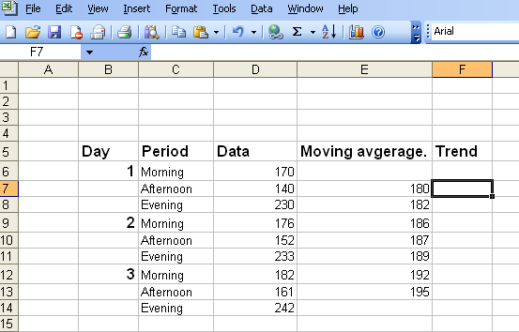

Solution:
Actual Data – Moving Average = trend

Actual Data | Moving average | Trend
140 | 180 | -40
230 | 182 | 48
176 | 186 | -10
152 | 187 | -35
233 | 189 | 44
182 | 192 | 10
161 | 195 | -34

Question No: 46 ( Marks: 3 )
A random sample of size n is drawn from normal population with mean 6 and S.D
1.2; if z = 4, 8 what is n?

Solution:

Question No: 47 ( Marks: 5 )
Use the given data to find the equation of the regression line. Round the final values to three significant digits, if necessary.
x y
1 143
3 116
5 100
7 98
9 90
Solution:
X | Y | XY | X^2 | Y^2
1 | 143 | 143 | 1 | 20449
3 | 116 | 348 | 9 | 13456
5 | 100 | 500 | 25 | 10000
7 | 98 | 686 | 49 | 9604
9 | 90 | 810 | 81 | 8100
Sum=25 | Sum=547 | Sum=2487 | Sum=165 | Sum=61609

Question No: 48 ( Marks: 5 )
Find the probability that a man flipping a coin gets the sixth head on the tenth flip.

Solution:

The probability of success (P) is 0.50, the number of trials (x) is 10, and the number of successes (r) is 6. We enter these values into the negative binomial formula.

Negative Binomial Distribution P(X = r) = _{n-1}C_{r-1} p^{r} (1-p)^{n-r}
(r) is 1. We enter these values into the negative binomial formula.
b*(x; r, P) = x-1Cr-1 * Pr * Qx - r
b*(10,6,0.50) = 10-1C6-1 * 0.50^6 * (1-0.5)^10-6
b*(10,6,0.50) = 9C5 * 0.015625 * (0.5)^4
b*(10,6,0.50) = 126 * 0.015625 * 0.0625
b*(10,6,0.50) = 0.123046

Question No: 49 ( Marks: 5 )
Calculate the mean, median and mode for the following set of data 1,2,8,5,4,9,3,4,5,8,6,2,4,5,8,8000.

Solution
1 | 2 | 2 | 3 | 4 | 4 | 4 | 5 | 5 | 5 | 6 | 8 | 8 | 8 | 9 | 8000

Question No: 50 ( Marks: 10 )
A family has 3 boys and 2 girls.
a) Find the number of ways they can sit in a row
b) How many ways are there if the boys and girls are each to sit together?

Solution:

a) The Five can sit in a row.
5 x 4 x 3 x 2 x 1 = 5! = 120
b) There are two ways to distribute them according to sex.
BBBGG or GGGBB
In each case boys can sit in 3 x 2 x 1 = 3! = 6 ways
The girls can sit 2 x 1 = 2! = 2 ways

Thus together they are…
= 2 x 3! x 2!
= 2 x 6 x 2
= 24 ways

Question No: 31 ( Marks: 2 )
At Pizza Parlor, in addition to cheese there are 8 different toppings. If you can order any number of toppings, then how many different toppings are possible?

Question No: 32 ( Marks: 2 )
Calculate the coefficient of variation where mean= 30 and S.D = 13.04.

Question No: 33 ( Marks: 2 )
Look at the diagram of the Normal Distribution.

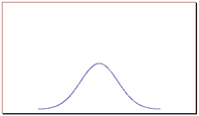

Can you guess by the diagram whether mean is greater than Standard Deviation or not?

Question No: 34 ( Marks: 3 )
Show that X and Y are uncorrelated by using the following table

X | 2 | 4
Y | 3 | 3

Question No: 35 ( Marks: 3 )
The Poisson distribution is the most commonly used to model the number of random occurrences of some phenomenon in a specified unit of space or time.

Give two examples of Poisson distribution from the daily life.

Question No: 36 ( Marks: 3 )
Define normal distribution?

Question No: 37 ( Marks: 5 )
There are 10 red marbles, 30 white marbles and 20 black marbles in a bag. What is the probability that you take out a marbel and it will be red or white?

Question No: 38 ( Marks: 5 )
If X is a normal random variable with mean (m) 100 and standard deviation (σ) is 10, find P(X<110).
( Use the following chart:

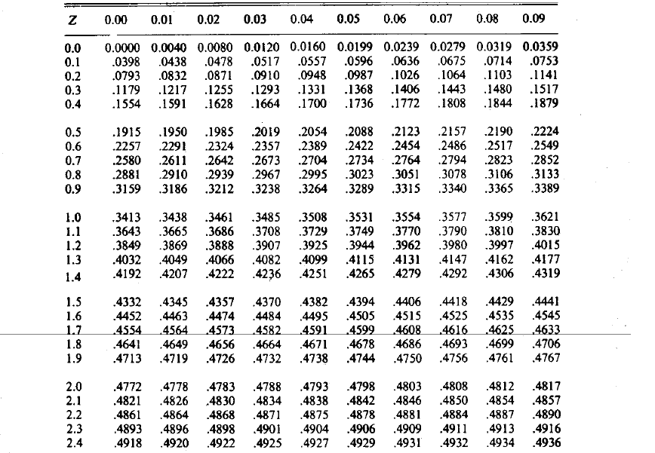

Question No: 39 ( Marks: 5 )
Find the variance and standard deviation of the following data
44, 50, 38, 96, 42, 47, 40, 39, 46, 50

