MTH101 Online Quiz#01 Fall 2012

Top of Form

Iqra  Quiz Start Time: 02:21 PM
  Time Left | 40  sec(s)

Question # 1 of 10 ( Start time: 02:21:12 PM) | Total Marks: 1
If f(x) = sec(x^5) and g(x) = tan(2x), then the derivative of f(x) - g(x) is ______. NOTE:- where x^n denotes the nth power of x.
Select correct option:

Top of Form

Iqra  Quiz Start Time: 02:21 PM
  Time Left | 45  sec(s)

Question # 2 of 10 ( Start time: 02:22:23 PM) | Total Marks: 1
At ‘x = pi’ , the derivative of ‘ f(x) = aCosx-bSinx ’ is------(note: pi=180 degrees)
Select correct option:

Top of Form

Iqra  Quiz Start Time: 02:21 PM
  Time Left | 64  sec(s)

Question # 3 of 10 ( Start time: 02:23:22 PM) | Total Marks: 1
The derivative of x^3+x^2 is………
Select correct option:

Top of Form

Iqra  Quiz Start Time: 02:21 PM
  Time Left | 35  sec(s)

Question # 5 of 10 ( Start time: 02:24:42 PM) | Total Marks: 1
If f (x) =Absolute( x + 1), then which of the following is NOT true about it. NOTE:- where x^n denotes the nth power of x .
Select correct option:

Top of Form

Iqra  Quiz Start Time: 02:21 PM
  Time Left | 55  sec(s)

Question # 6 of 10 ( Start time: 02:25:46 PM) | Total Marks: 1
h(t) =cos(t+1) is a composition of two functions , one is ‘Cos(t)’ and second is……….
Select correct option:

Top of Form

Iqra  Quiz Start Time: 02:21 PM
  Time Left | 55  sec(s)

Question # 7 of 10 ( Start time: 02:26:28 PM) | Total Marks: 1
If a car travels 150 miles over a straight road in 3 hours, then its average velocity during the trip is ………
Select correct option:

Top of Form

Iqra  Quiz Start Time: 02:21 PM
  Time Left | 79  sec(s)

Question # 8 of 10 ( Start time: 02:27:16 PM) | Total Marks: 1
Let y = x.x+1 Then the instantaneous rate of change of y with respect to x at the point -2 is
Select correct option:

Top of Form

Iqra  Quiz Start Time: 02:21 PM
  Time Left | 46  sec(s)

Question # 9 of 10 ( Start time: 02:27:33 PM) | Total Marks: 1
Average velocity is the slope of.....line
Select correct option:

Top of Form

Iqra  Quiz Start Time: 02:21 PM
  Time Left | 61  sec(s)

Question # 10 of 10 ( Start time: 02:28:31 PM) | Total Marks: 1
The function f(x) = |x| is differentiable in the interval (-infinity, 0)
Select correct option:

www.vustudy.com

MTH 101 QUIZ NO 1 Fall 2012
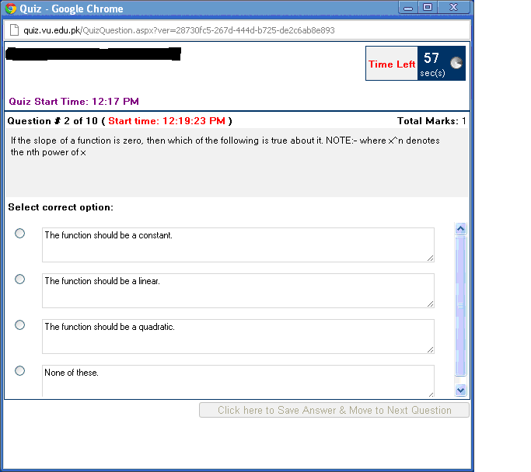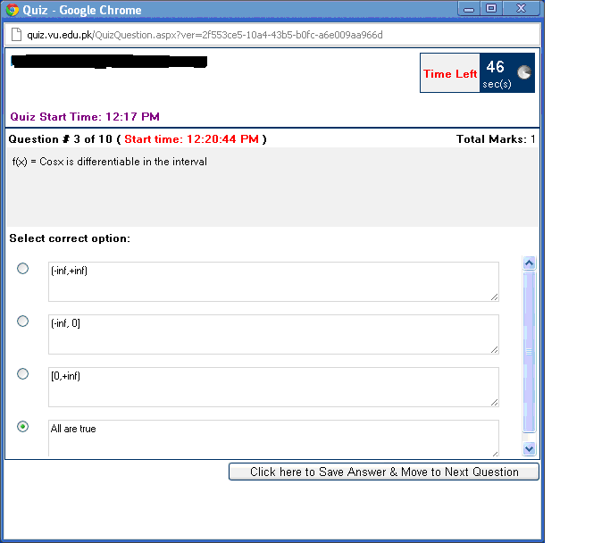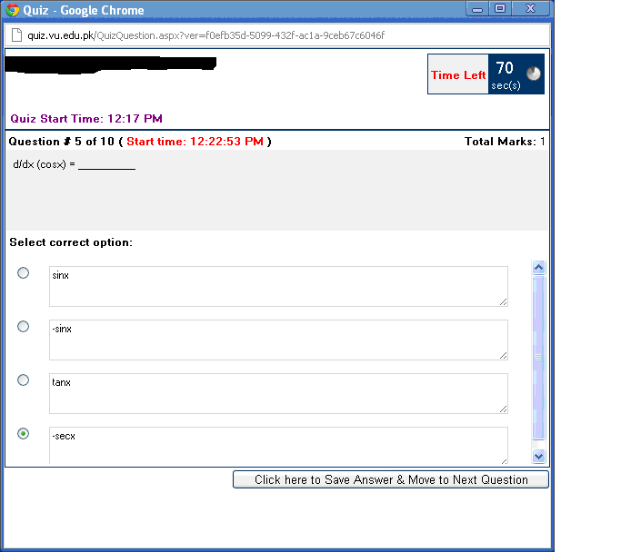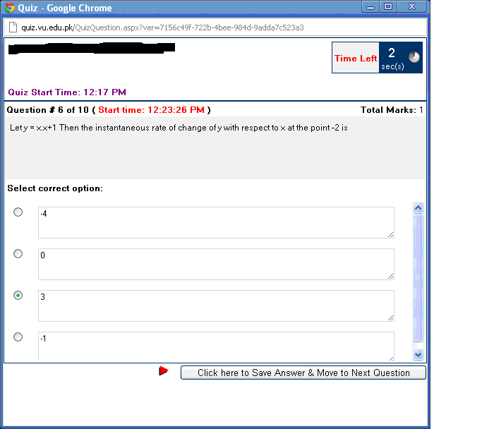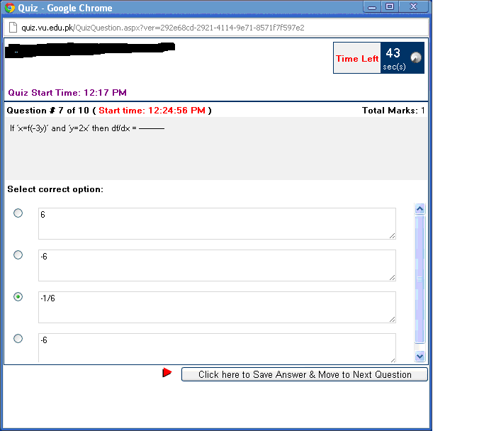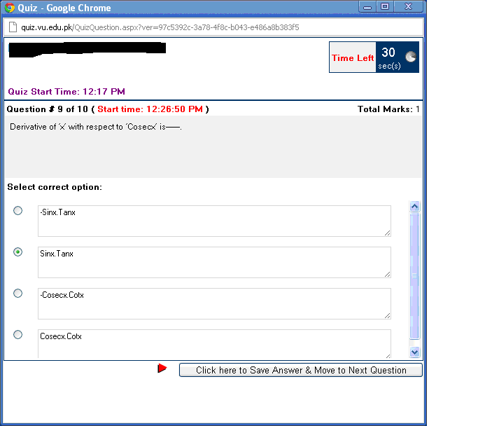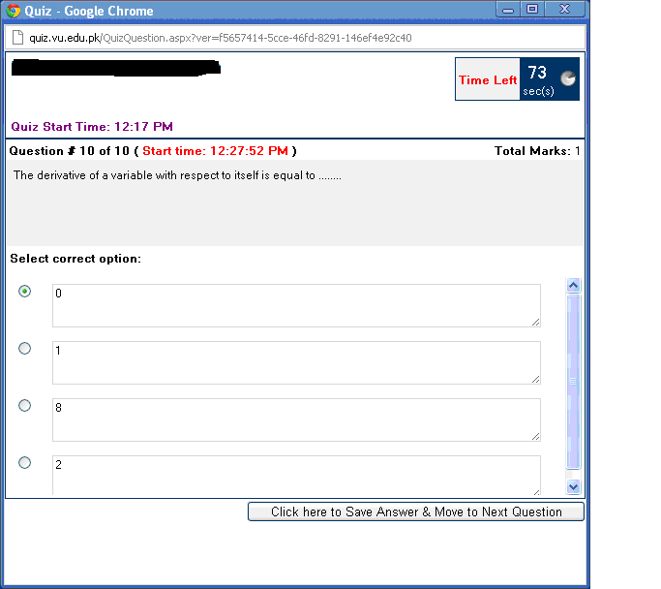

Bottom of Form
Bottom of Form
Bottom of Form
Bottom of Form
Bottom of Form
Bottom of Form
Bottom of Form
Bottom of Form
Bottom of Form

