ACC501 Solved MCQ’s No-1 Fall 2013

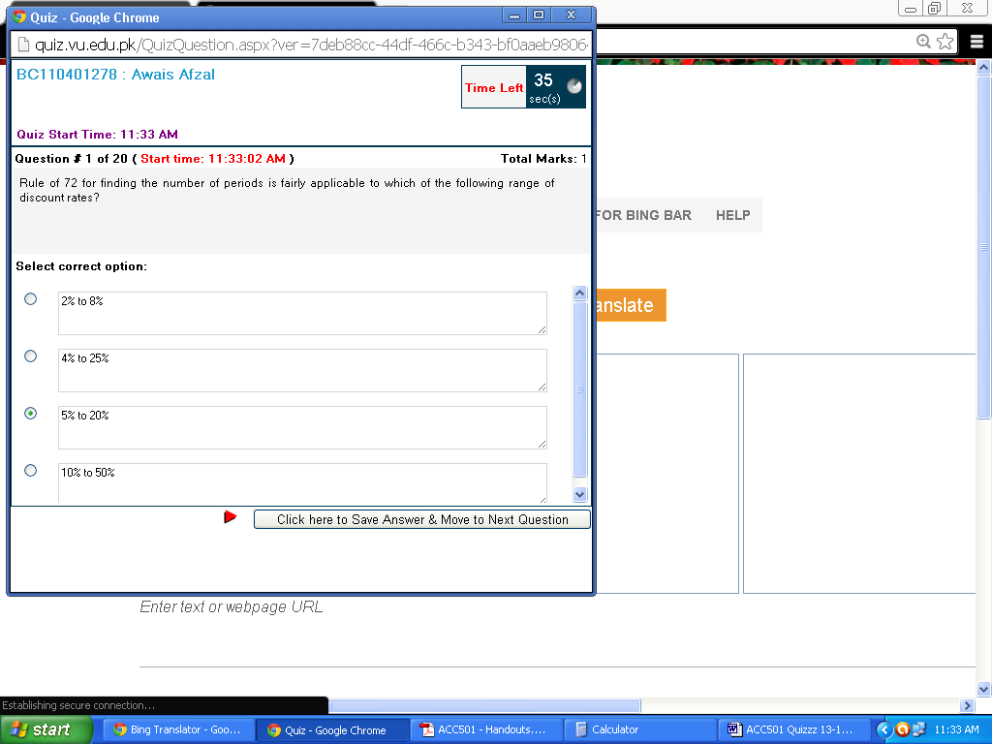

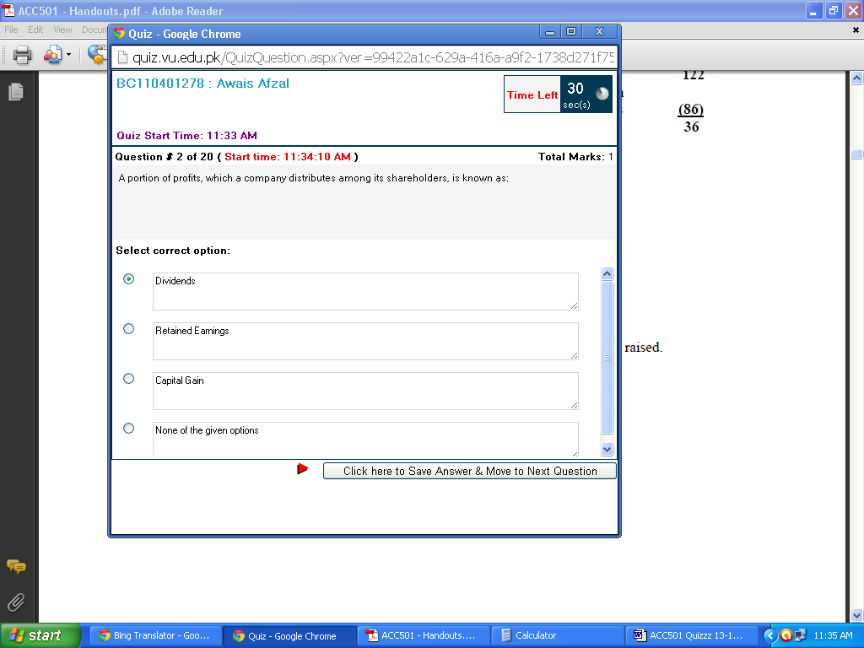

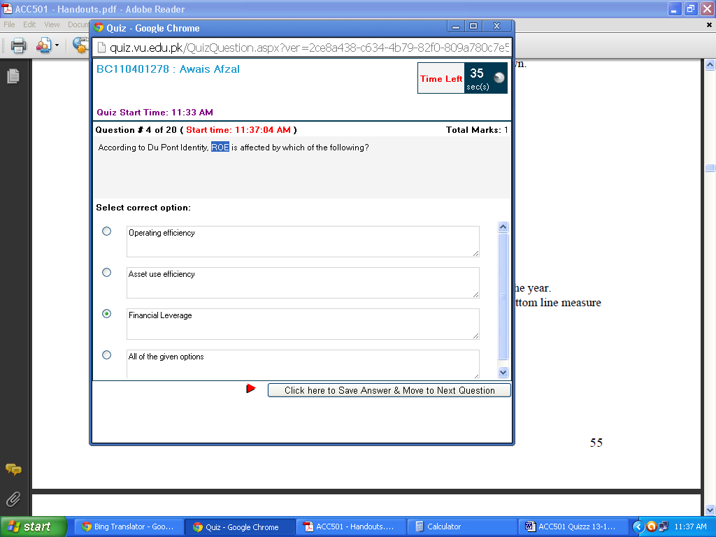

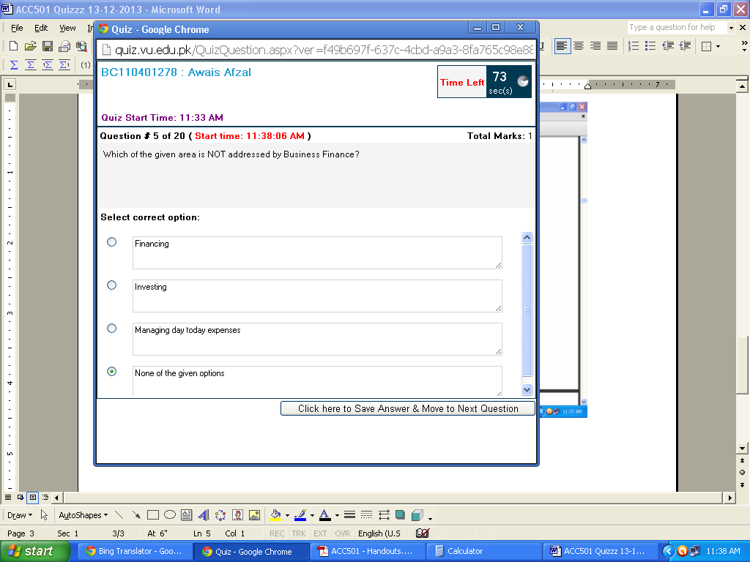

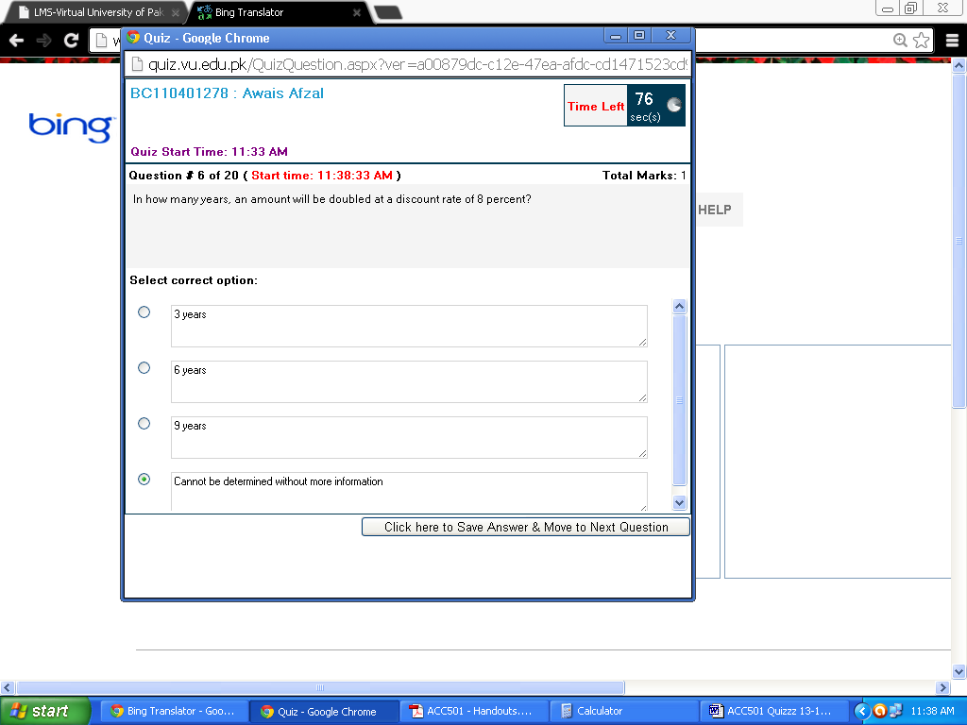

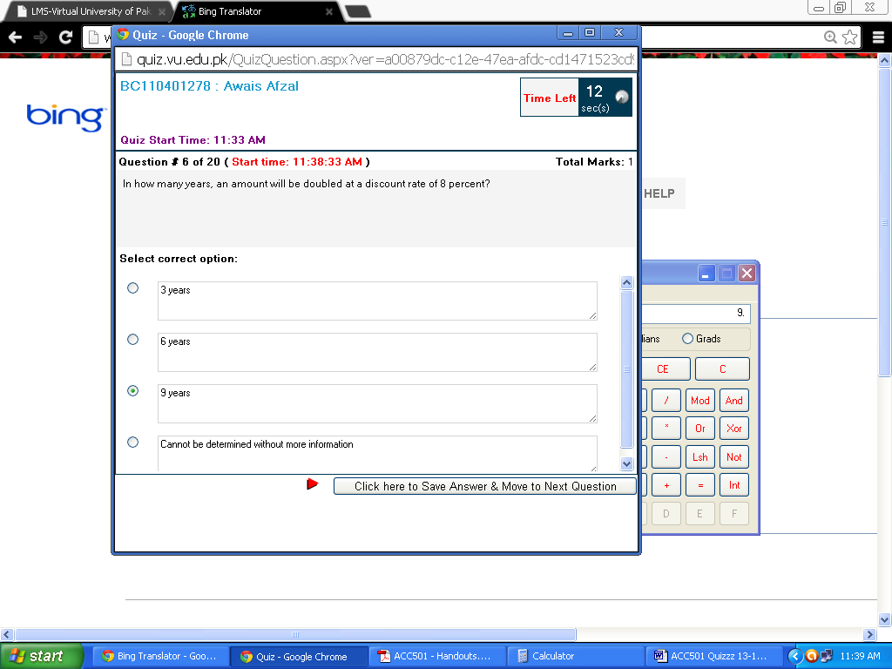

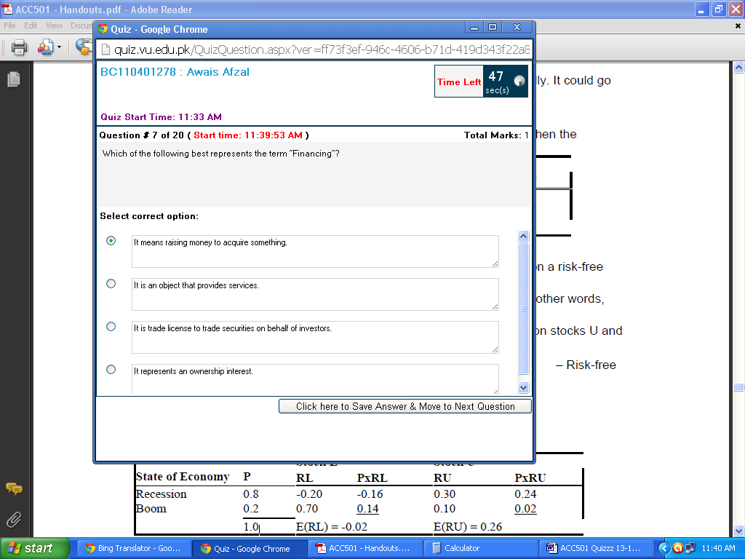

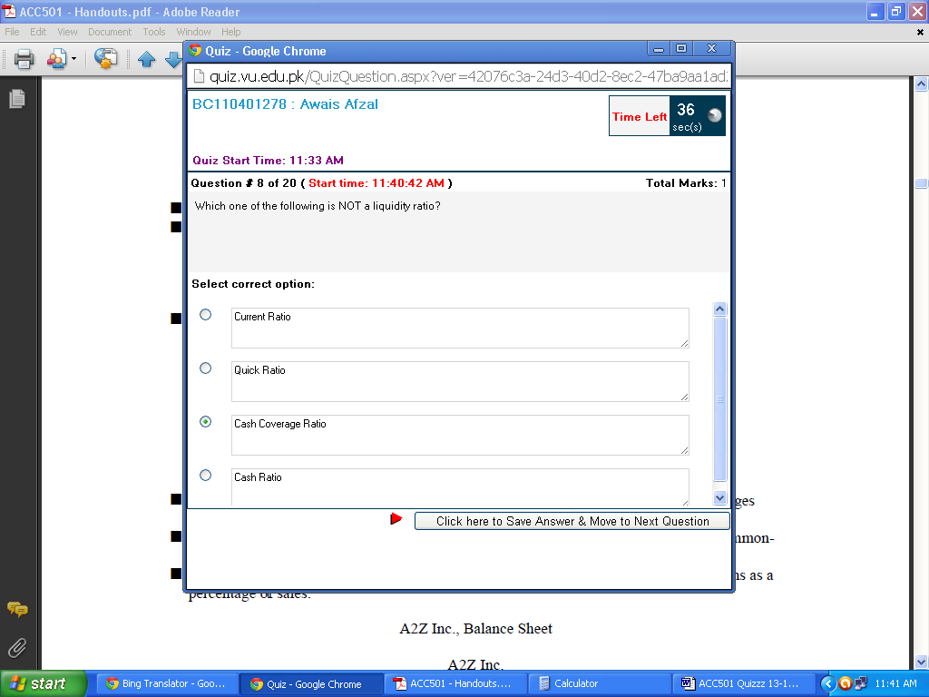

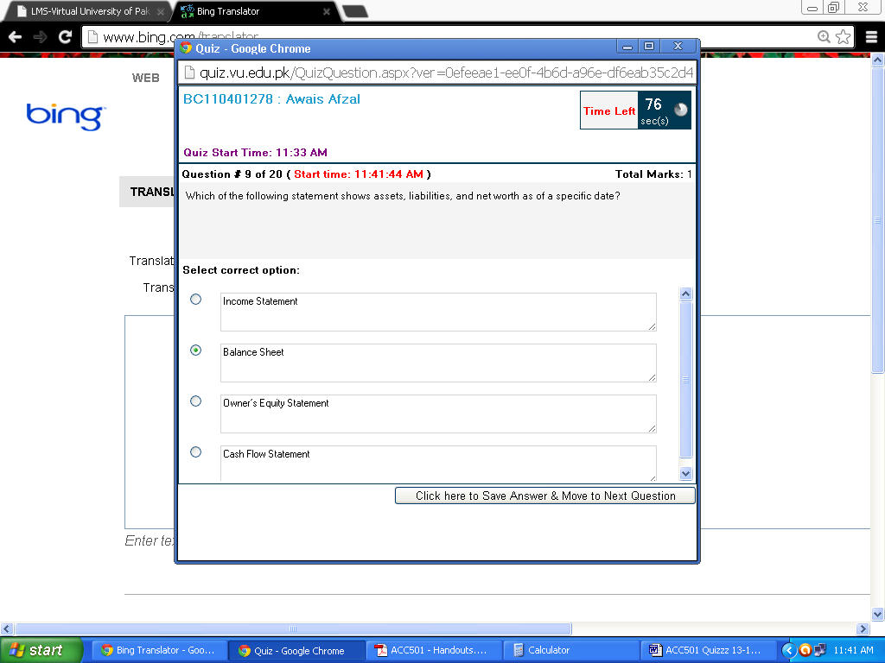

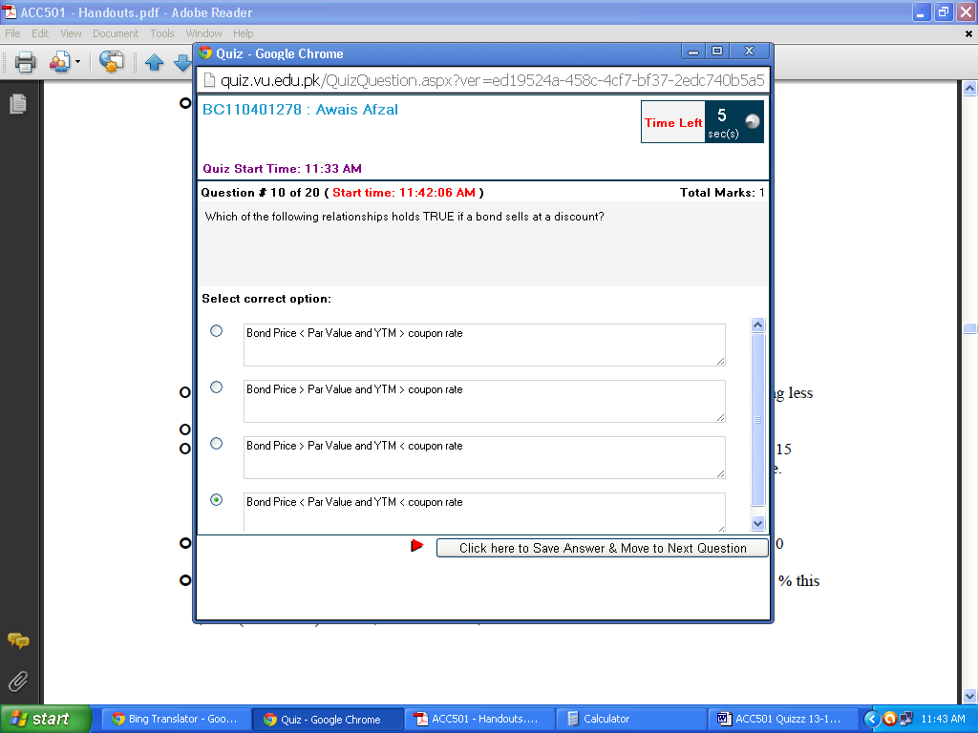

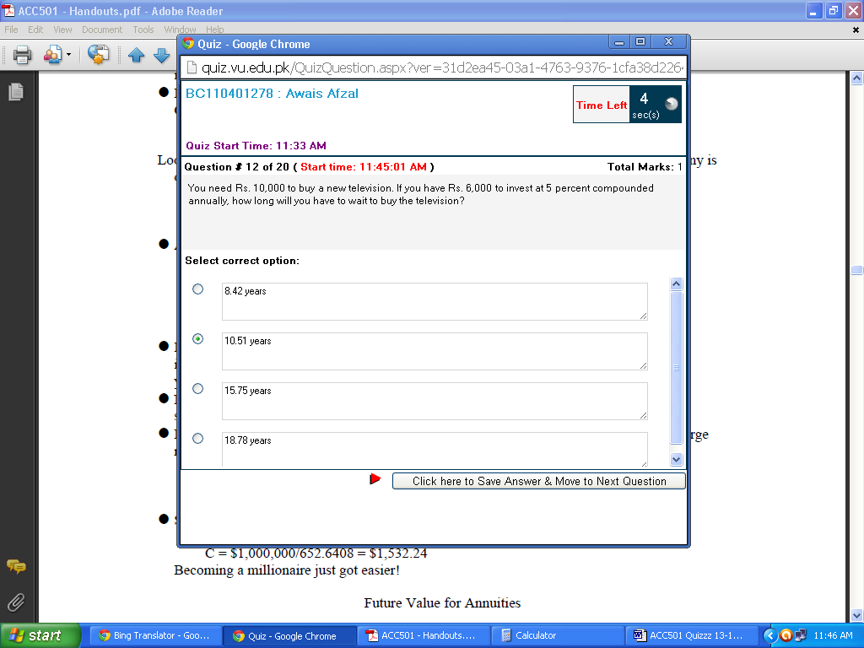

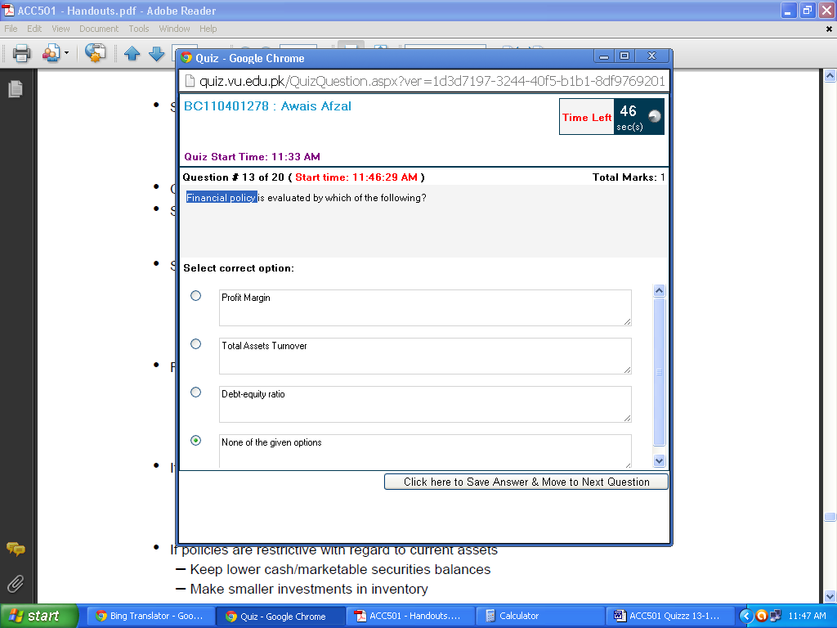

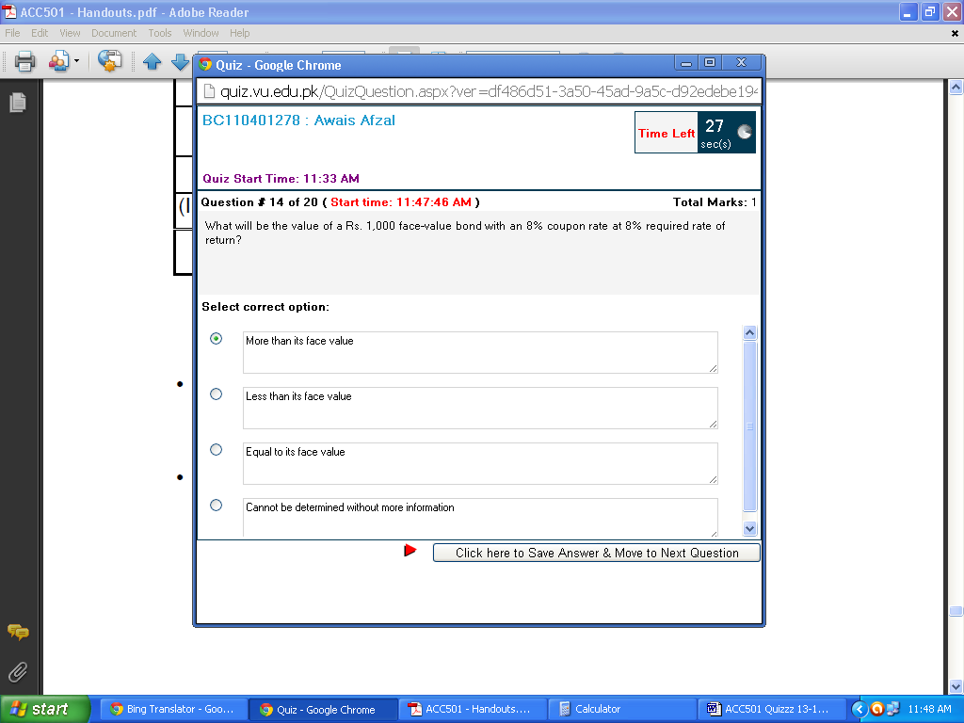

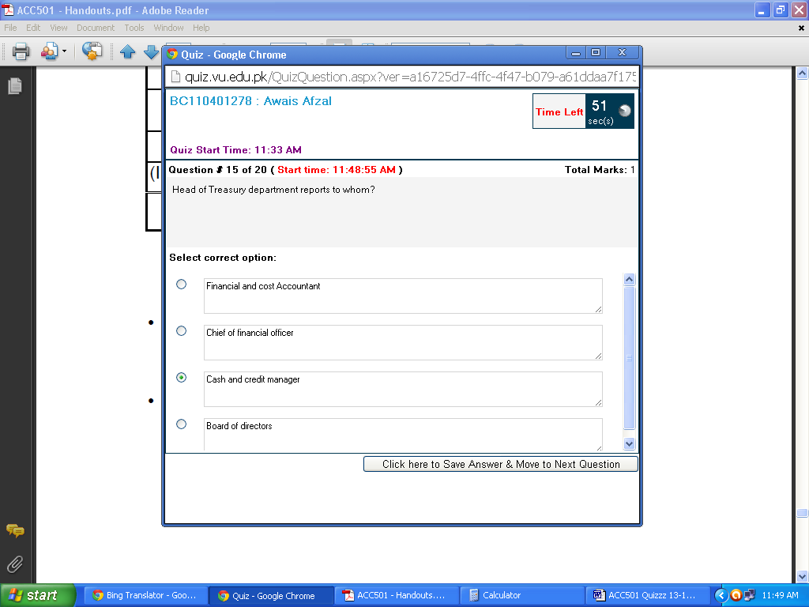

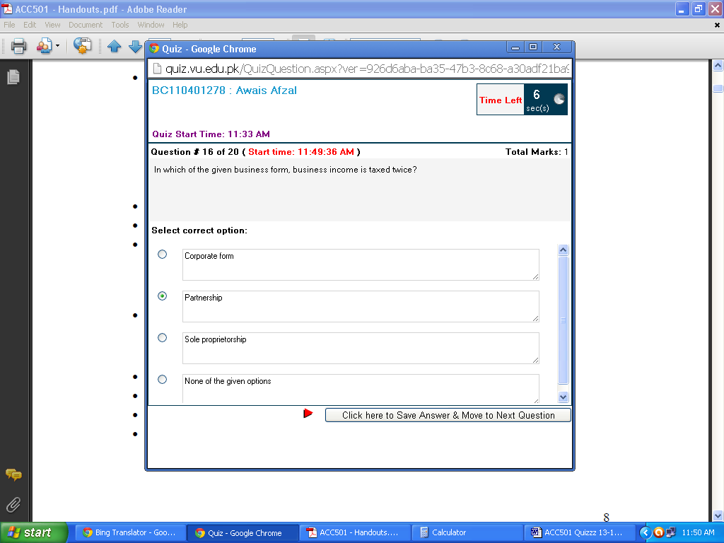

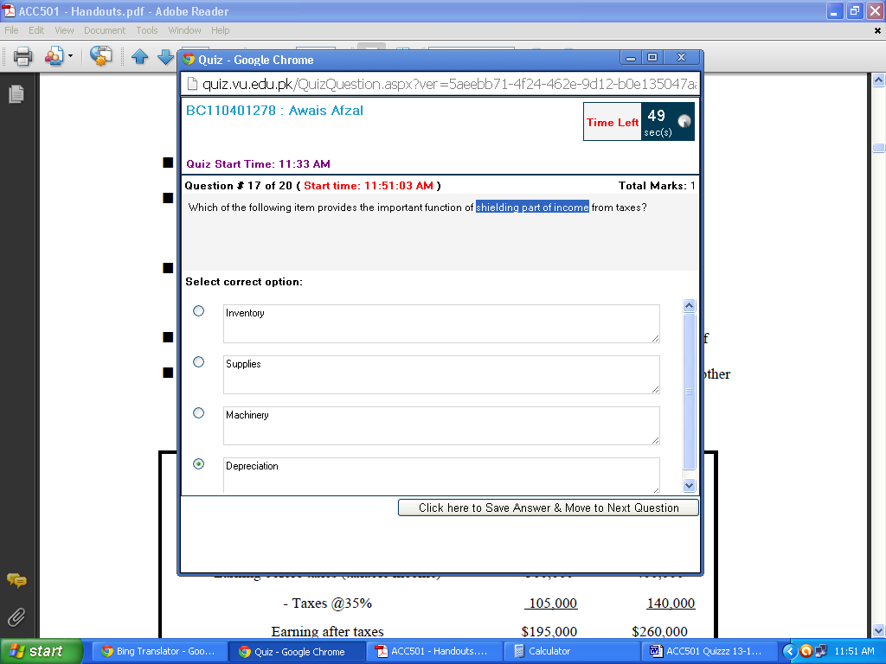

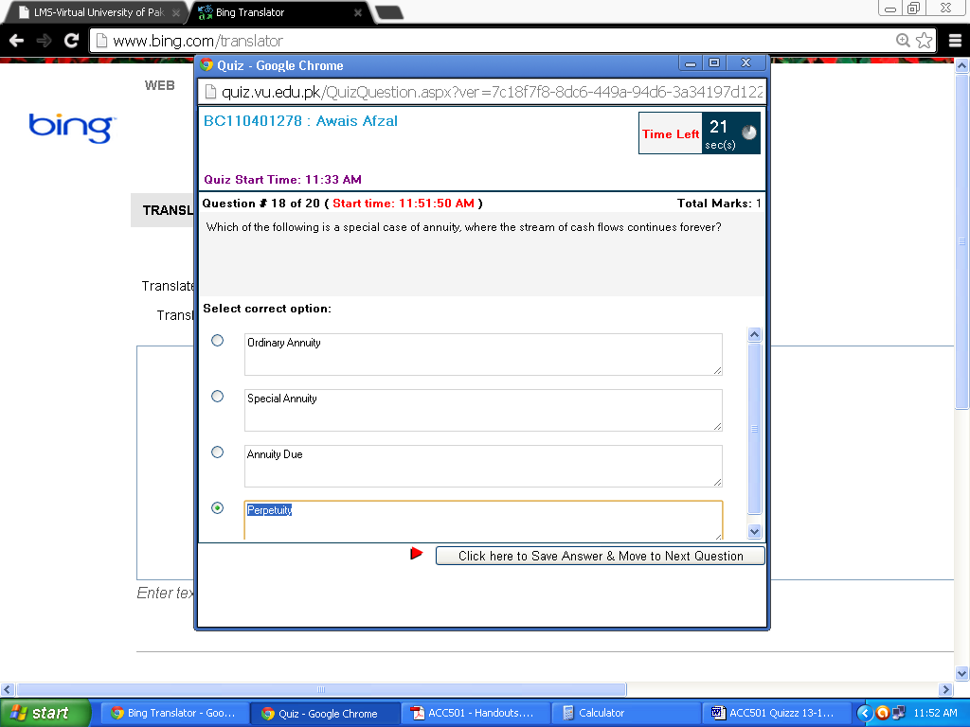

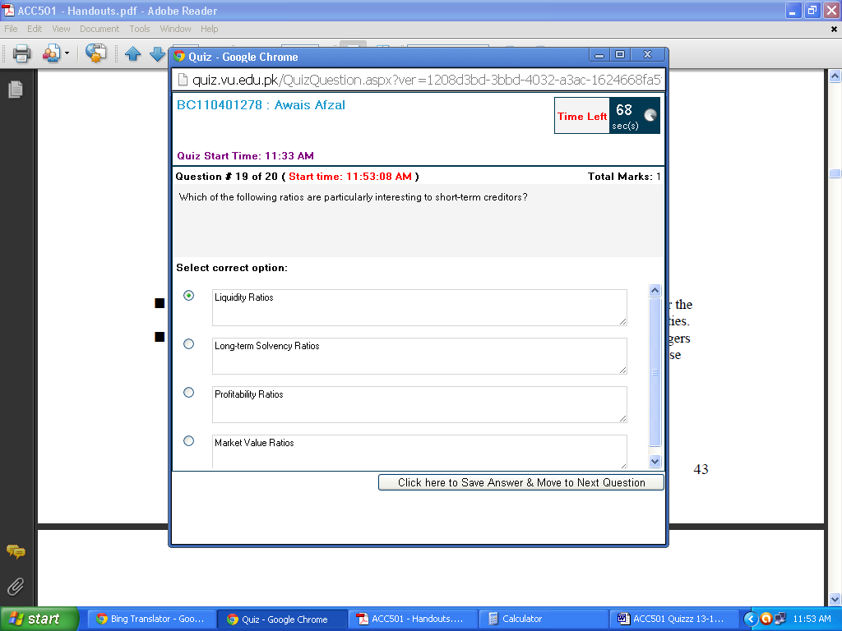

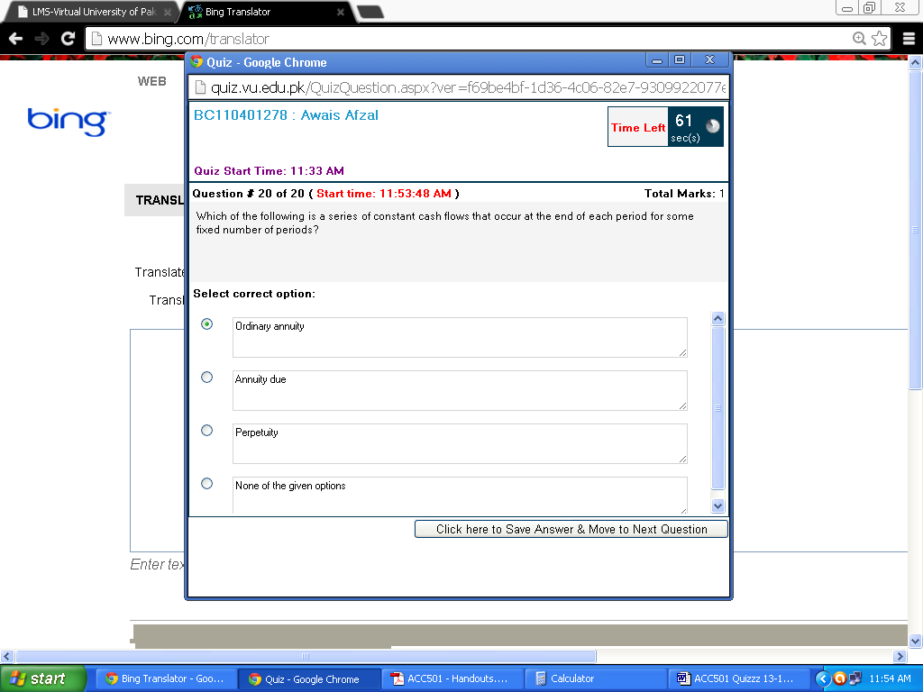

ACC501 Solved MCQ’s No-1 Fall 2013

1) Which of the following relationships holds TRUE if a bond sells at a discount?
Select correct option:
(Bond Price < Par Value and YTM > coupon rate)
Bond Price > Par Value and YTM > coupon rate
Bond Price > Par Value and YTM < coupon rate
Bond Price < Par Value and YTM < coupon rate

2) Which of the following item provides the important function of shielding part of income from taxes?
Select correct option:
Inventory
Supplies
Machinery
(Depreciation)

3) In which of the following form of business “All Business income is not considered as personal income”?
Select correct option:
(Corporate form)
Partnership
Sole proprietorship
None of the given options

4) which of the following is not a form of business organozation
Select correct option:
sole proprietorship
partnership
joint stock comapny
(cooperative Society)

5) Which of the given is (are) major difference(s) between net income and cash flow of the company?
Select correct option:
Accounts receivable only
Depreciation only
Accounts payable only
(All of the given options)

6) Which one of the following is NOT a liquidity ratio?
Select correct option:
Current Ratio
Quick Ratio
(Cash Coverage Ratio)
Cash Ratio

7) When corporations borrow, they generally promise to: I. Make regular scheduled interest payments II. Give the right of voting to bondholders III. Repay the original amount borrowed (principal) IV. Give an ownership interest in the firm
Select correct option:
I and II
(I and III)
II and IV
I, III, and IV

8) What will be the annual payment on a 7-year Rs. 18,000 loan that carries a 14% interest rate?
Select correct option:
Rs. 3,612.09
Rs. 3,872.26
(Rs. 4,197.46)
Rs. 4603.97

9) A company having a current ratio of 1 will have ________ net working capital.
Select correct option:
Positive
Negative
(zero)
None of the given options

10) Which of the following form of business organization is least regulated?
Select correct option:
(Sole-proprietorship)
General Partnership
Limited Partnership
Corporation

11) __________ shows the sources from which cash has been generated and how it has been spent during a period of time?
Select correct option:
Income Statement
Balance Sheet
(Cash Flow Statement)
Owner’s Equity Statement

12) In which of the following type of annuity, cash flows occur at the beginning of each period?
Select correct option:
Ordinary annuity
(Annuity due)
Perpetuity
None of the given options

13) Mr. Y and Mr. Z are planning to share their capital to run a business. They are going to employ which of the following type of business?
Select correct option:
Sole-proprietorship
(Partnership)
Corporation
None of the given options

14) Which of the following process can be defined as the process of generating earnings from previous earnings?
Select correct option:
Discounting
(Compounding)
Factorization
None of the given options

