MTH603 FINALTERM SUBJECTIVE
Question No: 50 ( Marks: 5 )
Solve by using the Newton Raphson method up to one iteration
(Note: Accuracy up to four decimal places is required)

Answer:
Q: Evaluate the integral By Trapezoidal Rule, h=0.2
Answer:
X | 0 | 0.2 | 0.4 | 0.6 | 0.8 | 1
Y= (x+1) | 1.0 | 1.2 | 1.4 | 1.6 | 1.8 | 2
Using trapezoidal rule, taking h=0.2
Q: Evaluate the integral By Simpson`s 3/8 rule. Take the interval h=1.
Answer:
X | 3 | 4 | 5
Y=(sin x+ cos x) | 1.0509 | 1.0673 | 1.0833
Q: Using Milne’s method find y(0.1) dy/dx=x-y/x+y, Y(0)=1.
Answer:
Q: y^{ʹ} =2t+3y then find next two derivatives w.r.t t or y.
Answer:
w.r.t t 2nd dravative Y’’ = 2 3rd dravative Y’’’ = 0
w.r.t y. 2nd dravative Y’’ = 3 3rd dravative Y’’’ = 0
Q: Make backward difference table from;
X | 0 | 3 | 4
Y | 4 | 7 | 9
Q:Solve by Gauss-elimination method:
1 0 8/3 x 8
0 -1 1/3 y = 0
0 0 -1/3 z 1
Q: Find y by Euler’s method when x=1, dy/dx=1/x+y, y(0)=1, h=1
Answer:
Q: Evaluate the integral by Simpson’s 1/3 rule , taking interval of .

Answer:
X | 0
Y=(sin x+ 1) | 1 | 1.7071

2012 paper1:
Q.1. State the sufficient condition of convergence of the iterative solution to the exact solution? 2m
Answer: page 72
A sufficient condition for convergence of the iterative solution to the exact solution is i=1, 2...n When this condition (diagonal dominance) is true, Jacobi’s method converges
Q.2. Evaluate the integral Using trapezoidal rule
Take h=1…..2m
Answer:
X | 3 | 4 | 5
Y= logx+1 | 0.6020 | 0.6989 | 0.7781
Using trapezoidal rule, taking h=1
Q3. Write the formula for finding the value of k₁ in the fourth order R-K Method. 2m
Answer: page 205
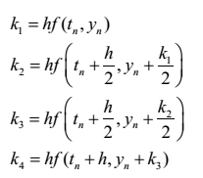
Q4. Write Adam-Moulton’s Predictor formula for finding the solution of a differential equation. 2m
Answer: page 223
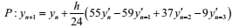
Q5. Obtain numerically the solution of y` = x² +2x+y², y (0) =1 Using Euler’s method to find y at x=1, h=1 …. 3m
Answer:
Y₁ = y₀ + hf(x₀, y₀)
Y₁ = 1+ (1) (1+1)
Y₁ = 1+2=3
Q6. If f(2)=-2.6146 and f(3)=4.7610, then find the first approximation using the Regula-Falsi method? 3m
Answer:
Q7. If in a solving a giving differential equations
……3m
Answer:
Q8. Find F(h), using Richardson’s extrapolation limit, while finding …………..3m
Answer:
Q.9
take h=1………5m
Answer:
X | 0 | 1 | 2 | 3
Y=(x²+x) | 0 | 2 | 6 | 12
Q10. Construct a backward difference table from the following values of x and y…..5m
x | -1 | 0 | 1 | 2 | 3
Y=f(x) | 10 | 2 | 10 | 62 | 80
Answer:
x | Y=f(x) | y
-1 | 10
0 | 2 | -8
1 | 10 | 8 | 16
2 | 62 | 52 | 44 | 28
3 | 80 | 18 | -34 | -78 | -106

Q11. From the following table of values, construct forward difference table…..5m
X | 1.00 | 1.05 | 1.10 | 1.15 | 1.20
y | 1.000 | 1.0247 | 1.0488 | 1.0724 | 1.0954
Answer:
x | Y=f(x) | y
1.00 | 1.000
1.05 | 1.0247 | 0.0247
1.10 | 1.0488 | 0.0241 | 0.0006
1.15 | 1.0724 | 0.0236 | -0.0005 | -0.0011
1.20 | 1.0954 | 0.023 | -0.0006 | -0.0001 | 0.0000

Q12. Use Runge-Kutta Method of order four to find the values of k₁k₂k₃k₄ for the initial value problem
y/= ½(2x³ +y),y(1)=2 taking h=0.1…………….5m
Answer:

2012 Paper2
Q1. Obtain numerically the solution of y/=x+y²,y(0)=2 Using Euler`s method to find y at x=1, h=1….2m
Answer:

Q2. If f(0)=3 and f(1)=9, then the next approximate value of the function using secant method….2m
Answer:
Q3. Write a backward difference formula of D²f(x)….2m
Answer:
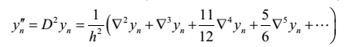
Q4. Write a formula for Simpson’s 1/3 rule……2m
Answer:
Q5.
…..3m
Answer:
X | 3 | 4 | 5
Y=(log x+ x) | 3.4771 | 4.6020 | 5.6989
Q6. Write the two steps of solving the linear equations using Gaussian Elimination method….3m
Answer:
In this method, the solution to the system of equations is obtained in two stages.
I) the given system of equations is reduced to an equivalent upper triangular form using elementary transformations
ii) The upper triangular system is solved using back substitution procedure

Q.7
….3m
Answer:

Q.8
…..3m
Asnwer:
x | 0 | 1 | 2 | 3
Y=(x² + x) | 0 | 2 | 6 | 12

Q.9
…..5m
Answer:
x | 0 | 1 | 2 | 3
Y=(x + 1) | 1 | 2 | 3 | 4

Q10. Find the dominant Eigen-value and the corresponding eigenvector of the matrix
….5m
Answer:
Q11. From the following table of values, construct backward difference table….5m
X | 0.1 | 0.2 | 0.3 | 0.4
F(x) | 1.10517 | 1.22140 | 1.34986 | 1.49182
Answer:
x | F(x)
0.1 | 1.10517
0.2 | 1.22140 | 0.11623
0.3 | 1.34986 | 0.12846 | 0.01223
0.4 | 1.49182 | 0.14196 | 0.0135 | 0.00127

Q12. Evaluate the integral
….5m
Answer:
x | 0 | 1 | 2 | 3 | 4
Y=(x² + 1) | 1 | 2 | 5 | 10 | 17

2 Marks Questions:
Q. Evaluate the integral
Using Simpson’s 1/3 rule. Where
Answer:
x | 0 | 1 | 2 | 3 | 4
Y= cos 2x | 0 | 0.9993 | 0.9975 | 0.9945 | 0.9902

Q. Difference between Jacobi’s Method and Gauss Seidel Method.
Answer:
The Jacobi method is a method of solving a matrix equation on a matrix that has no zeros along its main diagonal. Each diagonal element is solved for, and an approximate value plugged in. The process is then iterated until it converges. This algorithm is a stripped-down version of the Jacobi transformation method of matrix diagonalization.
The Gauss-Seidel Method
With the Jacobi method, the values of obtained in the th iteration remain unchanged until the entire th iteration has been calculated. With the Gauss-Seidel method, we use the new values as soon as they are known. For example, once we have computed from the first equation, its value is then used in the second equation to obtain the new and so on.

Q. if , then find next two derivation in term of t and/or y.
Answer:
w.r.t t 2nd dravative t’’ = 1 3rd dravative t’’’ = 0
w.r.t y. 2nd dravative Y’’ = 2 3rd dravative Y’’’ = 0

3 Marks Questions:
Q. Evaluate the integral
Using Simpson’s 3/8 rule. Where
Answer:
X
Y=sinx | 1.0 | 0.7071 | 0.0
Q. Use Ruge-Kutta method of order four to find value of and for initial value problem.
Answer:

Q. Find the residuals by relation method
With starting vector (0,0,0)
Answer:
Re-arrange the equation:
6x₁-3x₂+x₃=11
X₁-7x₂+x₃=10
2x₁+x₂-8x₃=-15
Thus, we get
R₁=11-6x₁+3x₂-x₃=11-6(0) +3(0)-(0) =11
R₂=10-x₁+7x₂-x₃=10-(0) +7(0)-(0) =10
R₃=-15-2x₁-3x₂+8x₃=-15-2(0)-3(0)+8(0)=-15
The largest residual in magnitude is R₃
Dx₃=
Similarly, we find the new residuals of large magnitude and relax it to zero, and so on.
5 Marks Questions:
Q. Evaluate the integral
Using Simpson’s 3/8 rule. Where
Answer:
x | 0 | 1 | 2 | 3
Y=(x² + 1) | 1 | 2 | 5 | 10

Q. Solve by Gauss Seidel iterative method to 3 decimal place up to
Two iterations
Answer:
The system is diagonally dominant
Q. Evaluate the integral
Using Simpson’s 1/3 rule. Where
Answer:
x | 0 | 1 | 2 | 3 | 4
Y=(x² + x+2) | 2 | 4 | 8 | 14 | 22

Q. Find the 2nd derivative of f(x) at x=0.3 using three point equation
x | 0.1 | 0.2 | 0.3 | 0.4 | 0.5 | 0.6
f(x) | 0.125 | 0.352 | 0.652 | 0.756 | 0.812 | 0.924
Answer:

Final 2013:
Q. Find Newton`s forward difference table from the following data
X | 0.0 | 0.1 | 0.2 | 0.3 | 0.4
F(x) | 1 | 0.9048 | 0.8187 | 0.7408 | 0.6703
…5m
Answer:
X | Y=f(x)
0.0 | 1
0.1 | 0.9048 | -0.0952
0.2 | 0.8187 | -0.0861 | 0.091
0.3 | 0.7408 | -0.0779 | 0.082 | -0.009
0.4 | 0.6703 | -0.0705 | 0.074 | -0.008 | 0.001
Q5.
…..3m
Answer:
X | 3 | 4 | 5
Y=(log x+ 2) | 2.4771 | 2.6020 | 2.6989

Q5.
…..2m
Answer:
X | 0
Y=(cos x+ 2) | 3 | 2.7071 | 2
Q. if F (h) =256.2354 and =257.1379, then find using Richardson`s extrapolation limit….2m
Answer:

7. if in solving given differential equation, 0.1, ,,, h=1, y3=2 then find the y4 by Adam–moulton’s predictor formula .
Answer:

12. using Adam-moulton’s predictor formula find the predicted value of f(0.4) from ordinary differential equation y’=1+2xy; y(0)=0; h=0.1
x | 0 | 0.1 | 0.2 | 0.3
y | 0 | .1007 | .2056 | .3199
Answer:
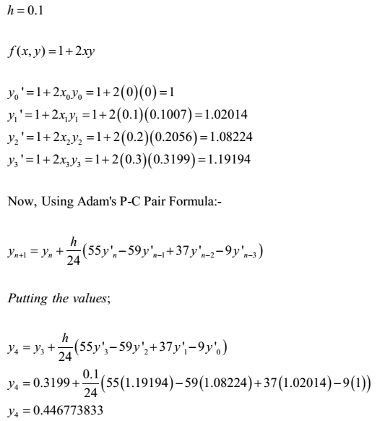
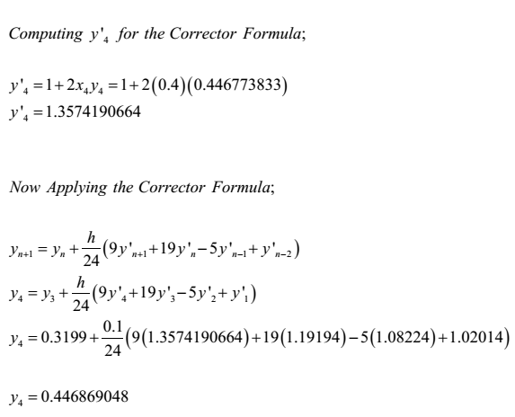

Q. using Adam-moulton’s predictor formula find the predicted value of f(0.4) from ordinary differential equation y’=1+xy; y(0)=0; h=0.1
x | 0 | 0.1 | 0.2 | 0.3
y | 0 | .1007 | .2056 | .3199
Answer:
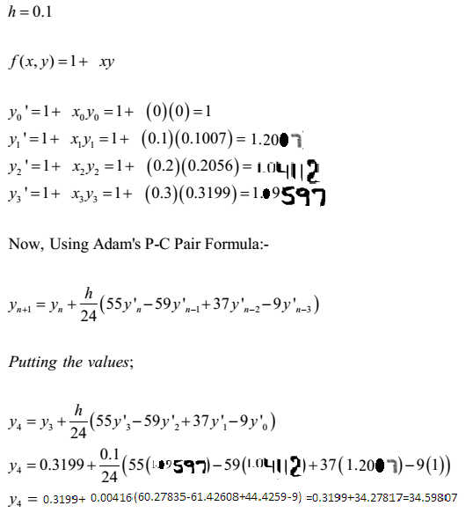
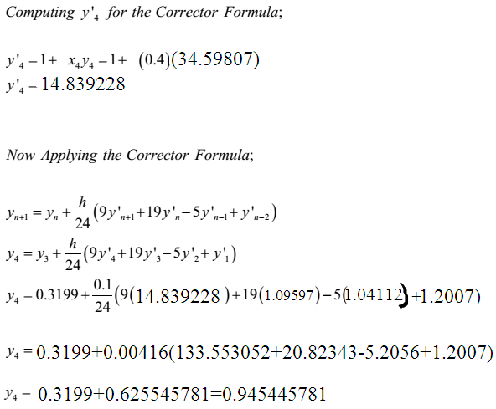

Q.2. Evaluate the integral Using trapezoidal rule
Take h=…..2m
Answer:
X | 0
Y= cosx | 1 | 0.7071
Using trapezoidal rule, taking h=
Q. obtain numerically the solution of
Answer:
Here: y(0)=2, x=1, h=1

Q5.
…..2m
Answer:
X
Y=sinx | 1 | 0.7071 | 0

Q. Prove that
Answer:
Q.2. Evaluate the integral Using trapezoidal rule
Take h=1…..2m
Answer:
X | 0 | 1 | 2
Y= (x²-3x+4) | 4 | 2 | 2
Using trapezoidal rule, taking h=1
Q12. Evaluate the integral
….5m
Answer:
x | 0 | 1 | 2 | 3 | 4
Y=(x² + 2) | 2 | 3 | 6 | 11 | 18
Q. Evaluate the integral Using Simpson’s 3/8 rule. Take h=1 (5)
Answer:
x | 0 | 1 | 2 | 3
Y=x | 0 | 1 | 2 | 3
Final 2014

- Write three equations for the following system of linear equation for Gauss Seidal Approximation Method (2)
83x+11y-4z=95
7x+52y++13z=104
3x+8y+29z=71

- Evaluate the integral
Using trapezoidal rule.
Take h=1 (2)
Answer:
X | 3 | 4 | 5
Y=(log x+2) | 2.4771 | 2.6020 | 2.6989
- Write a formula for finding the value of k₂ in fourth order R-K mrthod?(2)
Answer:
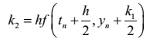
- If y’=t²-y, then find the next two derivatives in terms of t and or/y. (2)
Answer:
w.r.t t 2nd dravative t’’ = 2t 3rd dravative t’’’ = 2
w.r.t y. 2nd dravative Y’’ = 1 3rd dravative Y’’’ = 0

- Define intermediate value property? (3)
Answer:
If f(x) is a real valued continuous function in the closed interval a≤ x≤ b if f(a) and f(b) have opposite signs once; that is f(x)=0 has at least one root β such that a≤ b≤ β
Simply
If f(x) = 0 is a polynomial equation and if f(a) and f(b) are of different signs ,then f(x)=0 must have at least one real root between a and b.
Numerical methods for solving either algebraic or transcendental equation are classified into two groups.

- If in solving a given differential equation,
Then find y₄ by Milne’s Predictor formula. (3)
Answer:

- Evaluate the integral
Using trapezoidal rule. Take h=1. (3)
Answer:
X | 0 | 1 | 2 | 3 | 4
Y=x² | 0 | 1 | 4 | 9 | 16

- Obtain numerically the solution of
Y’=x²+2x+y², y(6)=1
Using Euler’s method to find y at x=1, h=1. (3)
Answer:
- Using predictor formula find the predicted value of y(0,4) from ordinary differential equation
Y’=x+y; y(0)=1, h=0.1
With the help of the following table (5)
X | 0 | 0.1 | 0.2 | 0.3
Y | 1 | 0.9097 | 0.8375 | 0.7816
Answer:
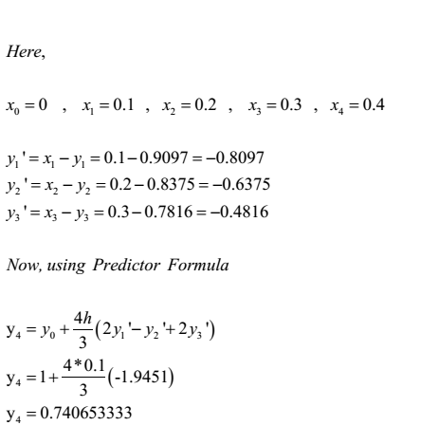
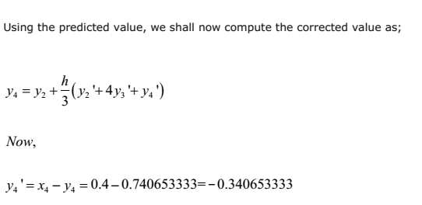
- Use the regula-falsi to solve the equation :
F(x)=e^{x}-3x=0. (Note only 1 iteration is required upto 4 decimal places is required) (5)
Answer:

- Evaluate the integral
Using Simpson’s 1/3 rule (5)
Answer:
x | 0 | 0.5 | 1 | 1.5 | 2 | 2.5 | 3 | 3.5 | 4
Y=x | 0 | 0.5 | 1 | 1.5 | 2 | 2.5 | 3 | 3.5 | 4

- Find y(1) for the following initial value problem y y’=x, y(0)=2
Using simple Euler’s method, taking h=1 (5)
Answer:

 | what is Simpson's 3/8th rule.
Answer: | The general formula for Simpson’s 3/8th rule is 3h/8[f0+3(f1+f2)+2f3+(3f4+f5)+2f6+…+3(fn-2+fn-1)+fn] Now if we have to calculate the integral by using this rule then we can simply proceed just write first and last vale and distribute all the remaining values with prefix 3 and 2 Like you have f0,f1,f2,f3,f4 Then the integral can be calculated as 3h/8[f0+f4+3(f1+f2)+2f4] If we have values like f0,f1,f2,f3,f4,f5 Then integral can be calculated as 3h/8[f0+3(f1+f2)+2f3+3f4+f5] Similarly proceeding in this fashion we can calculate the integral in this fashion
Question: | what is classic runge-kutta method
Answer: | The fourth order Runge-Kutta method is known as the classic formula of classic Runge-Kutta method. yn+1=yn+1/6(k1+2k2+2k3+k4) Where k1=hf(xn,yn) k2=hf(xn+h/2+yn+k1/2) k3=hf(xn+h/2,yn+k’2/2) k4=hf(xn+h,yn+k3)
Question: | What is meant by TOL?
Answer: | The TOL means the extent of accuracy which is needed for the solution. If you need the accuracy to two places of decimal then the TOL will be 10-2 .similarly the 10-3 means that the accuracy needed to three places of decimal. Suppose you have the root from last iteration 0.8324516 and 0.8324525 if we subtract both and consider absolute value of the difference 0.0000009 now it can be written as 0.09*10-5 so the TOL in this case is 10-5.similarly if we have been provided that you have to for the TOL 10-2 you will check in the same way. In the given equation you will solve the equation by any method and will consider some specific TOL and try to go to that TOL. Some time no TOL is provided and you are asked to perform to some specific no of iterations.
Question: | what is meant by uniqueness of LU method.
Answer: | An invertible (whose inverse exists) matrix can have LU factorization if and only if all its principal minors(the determinant of a smaller matrix in a matrix) are non zero .The factorization is unique if we require that the diagonal of L or U must have 1’s.the matrix has a unique LDU factorization under these condition . If the matrix is singular (inverse does not exists) then an LU factorization may still exist, a square matrix of rank (the rank of a matrix in a field is the maximal no of rows or column) k has an LU factorization if the first k principal minors are non zero. These are the conditions for the uniqueness of the LU decomposition.
Question: | how the valu of h is calculated from equally spaced data.
Answer: | Consider the following data x y 1 1.6543 2 1.6984 3 2.4546 4 2.9732 5 3.2564 6 3.8765 Here for h=2-1=3-2=1 x y 0.1 1.6543 0.2 1.6984 0.3 2.4546 0.4 2.9732 0.5 3.2564 0.6 3.8765 Here for the calculation of h =0.2-0.1=0.3-0.2=0.1 I think so that you may be able to understand .
 | what is the relation ship between p=0 and non zero p in interpolation.
Answer: | fp=fo+pDfo+1/2(p2-p)D2fo+1/6(p3-3p2+2p)D3fo+1/24(p4-6p3+11p2-6p)D4fo+… This is the interpolation formula For the derivative you will have to take the derivative of this formula w.r.t p and you will get f’p=1/h{Dfo+1/2(2p-1)D2fo+1/6(3p2-6p+2)D3fo+…} Now put here p=0 f’p=1/h{Dfo+1/2(0-1)D2fo+1/6(0-0+2)D3fo+…} So the formula becomes f’p=1/h{Dfo+D2fo/2+D3fo/3+…} so this is the relation ship between non zero and zero p no when you have to calculate p the you use formula p=x-xo/h so this is the impact of x.
Question: | What is chopping and Rounding off?
Answer: | Chopping and rounding are two different techniques used to truncate the terms needed according to your accuracy needs. In chopping you simply use the mentioned number of digits after the decimal and discard all the remaining terms. Explanation (1/3 - 3/11) + 3/20=(0.333333…-0.27272727..)+0.15=(0.333-0.272)+0.15 This is the three digit chopping.
Question: | When the forward and backward interpolation formulae are used?
Answer: | In interpolation if we have at the start then we use the forward difference formula and the formula to calculate p is x-x0/h. If the value of x lies at the end then we use Newton’s backward formula and formula to calculate the value of p is x-xn/h. Now I come to your question as in this case the value lies at the end so 6 will be used as the xn. This procedure has been followed by the teacher in the lectures. But some authors also use another technique that is if you calculate the value of p and that is negative then the origin is shifted to that value for which the value of p becomes positive. And then according to that origin the values of differences are used and you need not follow this procedure.
Question: | What is forward and backward difference operator and the construction of their table.
Answer: | For forward Dfr =fr+1 –fr Df0 = f1-f0 In terms of y Dyr+1=yr+1-yr D stands for the forward difference operator For backward Dfr =fr –fr-1 Df1 = f1-f0 In terms of y Dy1=y1-y0 Here D stands for backwards operator Now the construction of the difference table is based on X Y 1st forward 2nd forward 3rd forward x1 Y1 Y2-Y1=Dy0 x2 Y2 Y3-Y2=Dy1 x3 Y3 Y4-Y3=Dy2 x4 Y4 Now consider the construction of table for the backward table X Y 1st forward 2nd forward 3rd forward x1 Y1 Y2-Y1=Dy1 x2 Y2 Y3-Y2=Dy2 x3 Y3 Y4-Y3=Dy3 x4 Y4 Dear student this is the main difference in the construction of the forward and backwards difference table when you proceed for forward difference table you get in first difference the value Dy0 but in the construction of backwards difference table in the first difference you get Dy1 and in the second difference in the forward difference table you get D2 y0 and in the backward difference table the first value in the second difference is D2 y1. I think so you have made it clear.
Question: | What is Jacobi’s method?
Answer: | Jacobi’s Method It is an iterative method and in this method we first of all check either the system is diagonally dominant and, if the system is diagonally dominant then we will calculate the value of first variable from first equation in the form of other variables and from the second equation the value of second variable in the form of other variables and so on. We are provided with the initial approximations and these approximations are used in the first iteration to calculate first approximation of all the variables. The approximations calculated in the first iteration are used in the second iteration to calculate the second approximations and so on.
 | What is the condition that a root will lie in an interval.
Answer: | Suppose that you have a function f(x) and an interval [a,b]and you calculate both f(a)and f(b)if f(a)f(b)<0 then there must exist a root for this function in this interval.In simple words f(a) and f(b)must have opposite signs.
Question: | How the divided difference table is constructed?
Answer: | x y First difference Second difference Third difference 1 0.2 y0 y1-y0/x1-x0=sy0 sy1- sy0/x2-x0=s2y0 s2y0-s2y1/x3-x0=s3y0 s3y1-s3y0/x4x0 =s4y0 2 0.69 y1 y2-y1/x2-x1=sy1 sy2- sy1/x3-x1=s2y1 s2y2-s2y1/x4-x1=s3y1 3 0.985 y2 y3-y2/x3-x2=sy2 sy3- sy2/x4-x1=s2y2 4 1.2365 y3 y4-y3/x4-x3=sy3 5 2.3651 y4 This is the complete table showing the central differences . Here s stands for difference
Question: | What is Gauss-seidel Method
Answer: | It is also an iterative method and in this we also check either the system is diagonally dominant and, if so then we proceed on the same lines as in the Jacobi’s method. The difference in both is when we calculate a value of any variable that is instantly replaced by the previous value. If we have initial values like x1=0,x2=0 and x3=0 in the case of three variables in the first iteration we will use all the three values to calculate x1 but to calculate the value of x2 we will use the recent value of x1 which is calculated in the first iteration.
Question: | What is partial and full pivoting?
Answer: | Partial and full pivoting, In gauss elimination method when you have any of diagonal element aii zero it means the solution does not exist to avoid this we change the equation so that a non zero pivot is achieved .Now you have an argument matrix in which he elements in the first column are 1,3,4 respectively here in case of partial pivoting we will replace first element with the last element it is done by replacing the first equation with last equation it is known as partial pivoting. In full pivoting we change rows and columns but that is not implemented manually it is used in computers.
Question: | How the initial vector is choose in power method?
Answer: | Choose the initial vector such that the largest element is unity. But no problem with this you will precede with this vector as it is and will not change it. In the given question the initial vector is provided so you have to proceed with the given vector and will normalize this vector and normalizing this vector you will keep in mind that the greatest value should be unity. An eigenvector Vis said to be normalized if the coordinate of largest magnitude is equal to unity Actually this condition is for the normalization of the vectors when you have to normalize the vector you keep in mind that the larget entery in the vector must be 1 and so you take the largest element and divide the remaining values by the greatest value
 | What is meant by diagonally dominant system?
Answer: | A system a1x+b1y+c1z=d1, a2x+b2y+c2z=d2, a3x+b3y+c3z=d3 is said to be diagonally dominant if the following condition holds. |a1| => (greater or equal) |b1|+|c1| |b2| => (greater or equal) |a2|+|c2| |c3| => (greater or equal) |a3|+|b3|
Question: | State the sufficient condition for the convergence of the system of equation by iterative methods.
Answer: | A sufficient condition for convergence of iterative solution to exact solution is |a1| => (greater or equal) |b1|+|c1| |b2| => (greater or equal) |a2|+|c2| |c3| => (greater or equal) |a3|+|b3| For the system a1x+b1y+c1z=d1, a2x+b2y+c2z=d2, a3x+b3y+c3z=d3 Similarly for the system with more variables we can also construct the same condition
Question: | The calculation for numerical analysis should be done in degree or radians.
Answer: | All the calculation for numerical analysis should be done in radians not in degrees set your calculator in radians mode and suppose the value of pi=3.14.
Question: | How we can identify that Newton forward or backwards interpolation formula is to be used.
Answer: | If the value at which we have to interpolate is in the start of the table then we will use Newton’s forward interpolation formula if it is at the end of the table then we will use the Newton’s backward interpolation formula.
Question: | What is meant precision and accuracy?
Answer: | Precision and accuracy are two terms which are used in numerical calculations by precision we mean that how the values in different iterations agree to each other or how close are the different values in successive iterations. For example you have performed 3 different iterations and result of all the iteration are 1.32514,1.32516,31.32518 these three values are very precise as these values agree with each other . Accuracy means the closeness to the actual value. Suppose that you have calculated an answer after some iteration and the answer is 2.718245 and the actual answer is 2.718254 and the answer calculated is very accurate but if this answer is 2.72125 then it is not accurate.

 | What is meant by iterative methods?
Answer: | The methods which need one or more iterations are known as iterative methods like bisection method, Newton raphson method, and many other methods.
Question: | What is graphically meant by the root of the equation?
Answer: | If the graph of a function f(x) =0 cuts the x-axis at a point a then a is known as the root of the equation.
Question: | Q. What is the difference between open and bracketing method?
Answer: | In open methods we need only one initial approximation of the root that may be any where lying and if it is not very close then we have to perform more iteration and the example of open method is Newton raphson method. In bracketing method we bracket the root and find that interval in which root lies means we need two initial approximations for the root finding. Bisection method is an example of the bracketing method.
Question: | Condition for the existence of solution of the system of equations.
Answer: | If the |A| is not equal to zero then the system will have a unique solution if |A|=0 then the system will have no solution
Question: | Should the system be diagonally dominant for gauss elimination method?
Answer: | The system of equation need not to be diagonally dominant for Gauss elimination method and gauss Jordan method for both the direct method it is not necessary for the system to be diagonally dominant .it should be diagonally dominant for iterative methods like jacobie and gauss seidel method.
 | What is a trance dental equation?
Answer: | An equation is said to be a transcendental equation if it has trigonometric, exponential and logarithmic function or combination of all these functions.
Question: | How the value of h is calculated in interpolation?
Answer: | There are two types of data in the interpolation one is equally spaced and other is unequally spaced in equally spaced data we need to calculate the value of h that is calculated by subtracting any two consecutive values and taking their absolute value.
Question: | What is an algebraic equation?
Answer: | An algebraic equation is an equation which is purely polynomial in any variable. Supposed x2+3x+2=0, x4+3x2=0, y3+6y2=0 all are algebraic equations as these are purely polynomial in x and y variable.

Question: | What is Descartes rule of signs?
Answer: | The number of positive roots of an algebraic equation f(x) =0 can not exceed the no of changes in signs. Similarly the no of negative roots of negative roots of and algebraic equation can not exceed the no of changes in sign of equation f (-x) =0.
Question: | What are direct methods?
Answer: | The numerical methods which need no information about the initial approximation are known as direct methods like Graffee’s root squaring method.
What is direct methods of solving equations?
Answer: | Those methods which do not require any information about the initial approximation of root to start the solution are known as direct methods. The examples of direct methods are Graefee root squaring method, Gauss elimination method and Gauss Jordan method.All these methods do not require any type of initial approximation.
Question: | What is Iterative method of solving equations?
Answer: | These methods require an initial approximation to start. Bisection method, Newton raphson method, secant method, jacobi method are all examples of iterative methods
Question: | If an equation is a transcendental, then in which mode the calculations should be done?
Answer: | All the calculations in the transcendental equations should be done in the radian mode.
Question: | What is the convergence criterion in method of iteration?
Answer: | If be a root of f(x) =0 which is equivalent to I be any interval containing the point x= and will converge to the root provided that the initial approximation is chosen in I
Question: | When we stop doing iterations when Toll is given?
Answer: | Here if TOL is given then we can simply find the value of TOL by subtracting both the consecutive roots and write it in the exponential notation if the required TOL is obtained then we stop.
 | What is inherent error and give its example.
Answer: | It is that quantity of error which is present in the statement of the problem itself, before finding its solution. It arises due to the simplified assumptions made in the mathematical modeling of a problem. It can also arise when the data is obtained from certain physical measurements of the parameters of the problem. e.g. if writing 8375 instead of 8379 in a statement lies in the category of inherent error.
Question: | What is local round-off error?
Answer: | At the end of computation of a particular problem, the final results in the computer, which is obviously in binary form, should be converted into decimal form-a form understandable to the user-before their print out. Therefore, an additional error is committed at this stage too. This error is called local round-off error.
Question: | What is meant by local truncation error?
Answer: | Retaining the first few terms of the series up to some fixed terms and truncating the remaining terms arise to local truncation error.
Question: | What is transcendental equation and give two examples.
Answer: | An equation is said to be transcendental equation if it has logarithmic, trigonometric and exponential function or combination of all these three. For example it is a transcendental equation as it has an exponential function These all are the examples of transcendental equation.
Question: | What is meant by intermediate value property?
Answer: | If f(x) is a real valued continuous function in the closed interval if f(a) and f(b) have opposite signs once; that is f(x)=0 has at least one root such that Simply If f(x)=0 is a polynomial equation and if f(a) and f(b) are of different signs ,then f(x)=0 must have at least one real root between a and b.
 | What is the order of global error in Simpson’s 3/8 rule?
Answer: | The global error in Simpson’s 3/8 rule is of the order of 0(h4).
Question: | Which equation models the rate of change of any quantity with respect to another?
Answer: | An ordinary differential equation models the rate of change of any quantity with respect to another.
Question: | By employing which formula, Adam-Moulton P-C method is derived?
Answer: | Adam-Moulton P-C method is derived by employing Newton’s backward difference interpolation formula.
Question: | What are the commonly used number systems in computers?
Answer: | Binary Octal Decimal Hexadecimal
Question: | If a system has the base M, then how many different symbols are needed to represent an arbitrary number? Also name those symbols.
Answer: | M 0, 1, 2, 3, … , M-1
 | Is the order of global error in Simpson’s 1/3 rule equal to the order of global error in Simpson’s 3/8 rule?
Answer: | Yes. The order of global error in Simpson’s 1/3 rule equal to the order of global error in Simpson’s 3/8 rule.
Question: | What is the order of global error in Trapezoidal rule?
Answer: | The global error in Trapezoidal rule is of the order of 0(h2).
Question: | What is the formula for finding the width of the interval?
Answer: | Width of the interval, h, is found by the formula h=(b-a)/n
Question: | What type of region does the double integration give?
Answer: | Double integration gives the area of the rectangular region.
Question: | Compare the accuracy of Romberg’s integration method to trapezoidal and Simpson’s rule.
Answer: | Romberg’s integration method is more accurate to trapezoidal and Simpson’s rule

Important Topics
Newton's Forward Diffrence & Backward Difference (Interpolation)
Newton's Forward Diffrence & Backward Difference (Differentiation)
Trapezoidal Rule (***Very Important***)
Simpson's 1/3 Rule
Simpson's 3/8 Rule
Euler's Method (**Important**)
Two Point Formula for Differentiation (**Important**)
Three Point Formula for Integration (**Important**)
Runge-Kutta Second Order Method (**Important**)
Runge-Kutta Fourth Order Method (***Very Important***)
Adam-Moulton Method {Predictor, Corrector and Error} (**Important**)
Milne Method {Predictor, Corrector and Error}
mcqs was mostly from forward backward interpolating and runge kutta and lagrange 1/3 simpson and trapezoidal rule
2 marks question : adam moultan predictor corrector formula
2 marks question : milne predictor corrector formula
3 marks question : formula of k3 of runge kutta
3 marks question : 1/3 simpson question
3 marks : trapezoidal rule question
5 marks : euler related
5 marks: trapezoidal
5 marks: milne predictor corrector formula question in the handouts on page 211(find f(0.4) from ordinary differencial equation )

