MTH603 Final term Solved MCQ’s

Question # 1 of 10 ( Start time: 04:40:08 PM ) | Total Marks: 1
The determinant of a diagonal matrix is the product of the diagonal elements.
- True
- False

Question # 2 of 10 ( Start time: 04:40:58 PM ) | Total Marks: 1
Power method is applicable if the eigen vectors corresponding to eigen values are linearly independent.
- True
- false

A 3 x 3 identity matrix have three and different eigen values.
- True
- False

If n x n matrices A and B are similar, then they have the different eigenvalues (with the same multiplicities).
- True
- False

The Jacobi’s method is a method of solving a matrix equation on a matrix that has ____ zeros along its main diagonal.
- No
- At least one
An eigenvector V is said to be normalized if the coordinate of largest magnitude is equal to ______.
- Unity
- zero

The Gauss-Seidel method is applicable to strictly diagonally dominant or symmetric positive definite matrices A.
- True
- False

The determinant of a _______ matrix is the product of the diagonal elements.
- Diagonal
- Upper triangular
- Lower triangular
- Scalar

Waisay main nay is ka answer Diagnol keea tha….par yeh charon options theek hain….
You can confirm it from internet…

Jab main yeh MCQ kar raha tha tou tab hi mujhay is par shak ho raha tha….kyun k upper aur lower triangular matrices tou linear algebra mein bhi bahut ziada bataye gaye tou yeh property wahan se hi yaad thi…

Eigenvalues of a symmetric matrix are all _________.
- Real
- Zero
- Positive
- Negative

The Power method can be used only to find the eigen value of A that is largest in absolute value—we call this eigen value the dominant eigen value of A.
- True
- False

The characteristics polynomial of a 3x 3 identity matrix is __________, if x is the eigen values of the given 3 x 3 identity matrix. where symbol ^ shows power.
- (x-1)^3
- (x+1)^3
- x^3-1
- x^3+1

For differences methods we require the set of values.
- True
- False

If n x n matrices A and B are similar, then they have the different eigenvalues (with the same multiplicities).
- True
- False

If x is an eigen value corresponding to eigen value of V of a matrix A. If a is any constant, then x – a is an eigen value corresponding to eigen vector V is an of the matrix A - a I.
- True
- False
a ko agar aap lambda se replace kar dain tou baat clear ho jaye gi….labda ki jagah a use keea gaya hai tou is liay yeh working thora sa confuse karti hai…
Central difference method seems to be giving a better approximation, however it requires more computations.
- True
- False

Iterative algorithms can be more rapid than direct methods.
- True (main nay true hi keea tha, aap isay dekh lena)
- False

Central Difference method is the finite difference method.
- True
- False

MTH603 Numerical Analysis

Exact solution of 2/3 is not exists.
TRUE
FALSE

The Jacobi’s method is
a method of solving a matrix equation on a matrix that has ____ zeros along its main diagonal.

no
atleast one

A 3 x 3 identity matrix have three and __________eigen values.
same
different

Eigenvalues of a symmetric matrix are all _______ .
real
complex
zero
positive

The Jacobi iteration converges, if A is strictly diagonally dominant.
TRUE
FALSE

Below are all the finite difference methods EXCEPT _________.

jacobi’s method
newton's backward difference method
Stirlling formula
Forward difference method

If n x n matrices A and B are similar, then they have the same eigenvalues (with the same multiplicities).
TRUE
FALSE

If A is a nxn triangular matrix (upper triangular, lower triangular) or diagonal matrix , the eigenvalues of A are the diagonal entries of A.

TRUE
FALSE

The characteristics polynomial of a 3x 3
identity matrix is __________, if x is the eigen values of the given 3 x 3 identity matrix. where symbol ^ shows power.

(x-1)^3
(x+1)^3
x^3-1
x^3+1

Two matrices with the same characteristic polynomial need not be similar.

TRUE
FALSE

Top

i have attempt mth 603 today........... my paper was power method 5
marks , from vactor 3 marks, Newton_Repshon's forwrd distnce formula
5 marks.,define extra polation 2 marks ,, and most of MCQ's from ,
Newton_Repshon's method ,or 18 to 22 lec's

question 29: Distinguish between Related and unrelated diversification with example 5marks
question 30 Five porters Model 5 marks
question 31: conecntric diversification two example 3marks
question 32 significant of R&D for an organization 3marks
Which of the following period strategic management was considered to be cure for all problems?
Mid 1950s to mid 1960s
Mid 1960s to mid 1970s
Mid 1970s to mid 1980s
Mid 1980s to mid 1990s
Which of the following is not a pitfall an organization should avoid in strategic planning?
Select correct option:
Failing to involve key employees in all phases of planning
Involving all managers rather than delegating planning to a planner
Top managers not actively supporting the strategic planning process
Doing strategic planning only to satisfy accreditation or regulatory requirements
which of the following are the factors that concern the nature and direction of the economy
in which a firm operates?
Select correct option:
Technological
Ecological
Social
Economic
Which of the following best describes this statement; “a Systematic and ethical process
for gathering and analyzing information about the competition’s activities and general
business trends to further a business’ own goals”?
Select correct option:
External assessment
Industry analysis
Competitive intelligence program
Business ethics
According to Porter, which strategy offers products or services to a small range of
customers at the lowest price available on the market?
Select correct option:
Low cost
Best value
Cost focus
Differentiation
Long-term objectives includes all of the following except:
Measurable
Reasonable
Varying
Consistent

Which one of the following is NOT is a basic mission of a competitive intelligence program?
To provide a general understanding of an industry
To provide a general understanding of a company’s competitors
To identify industry executives who could be hired by the firm
To identify potential moves a competitor might make that would endanger a firm

While preparing an External Factor Evaluation Matrix, a total score of 0.8 indicates that:
Firm is taking advantages of strengths and avoiding threats
Firm is taking no advantage of opportunities and is avoiding threats
Firm is not taking advantages of opportunities and is not avoiding threats
Firm is taking advantage of opportunities and is avoiding the threats

Top

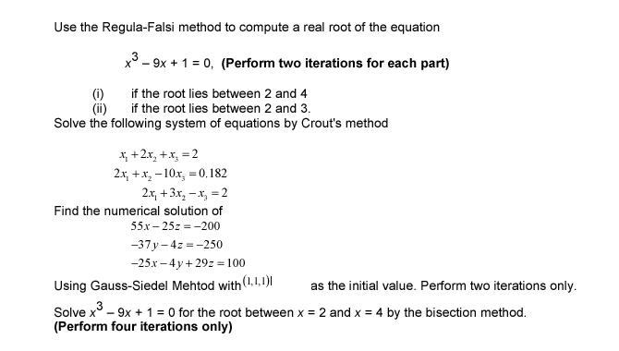

Top

MTH603-Numerical Analysis
SEMESTER FALL 2005
www.vupages.com

Approximate the integralusing Simpson's 1/3 rule and calculate the percentage error. (Take result up to 4 decimal places)
Note: In order to get full marks do all necessary steps.

Construct a forward difference table for the following values
x 0.1 0.3 0.5 0.7 0.9 1.1 1.3
y 0.003 0.067 0.148 0.248 0.37 0.518 0.697

Note : In order to get full marks do all necessary steps.

Solve the system
by Gauss Seidal Method, taking (0, 0, 0)t as initial approximation(Two iterations only and take result up to 4 decimal places )

Note : In order to get full marks do all necessary steps

Let, use cubic Lagrange interpolation based on the nodesto approximate f(1.5) and f(1.3).

Note : In order to get full marks do all necessary stepsSolution

Approximate the Dominant Eigenvalue and corresponding Eigenvector for the matrix
by using Power Method. Start with. (Five iterations only and take result up to 4 decimal places)

Note : In order to get full marks do all necessary steps

Top

